

HL-MCK AUTOMATION ANTIDETECT BROWSER (HL-MCK)

CAPSTONE PROJECT REPORT
Report 3 – Software Requirement Specification

– Hanoi, April 2026 –
Table of Contents
I. Record of Changes 3
II. Software Requirement Specification 4
1. Overall Requirements 4
1.1 Context Diagram 4
1.2 Main Workflows 5
1.3 User Requirements 5
1.4 System Functionalities 23
1.5 Entity Relationship Diagram 26
2. Use Case Specifications 29
2.1 Activation 29
2.2 Browser Profile Management 31
. 32
2.3 Proxy Management 39
2.4 Script Management 46
2.5 Logging 61
2.6 Browser Engine 64
2.7 API Management 67
2.8 App Setting 108
2.9 Web Application 111
3. Functional Requirements 125
4. Non-Functional Requirements 145
4.1 External Interfaces 145
4.2 Quality Attributes 146
5. Requirement Appendix 147
5.1 Business Rules 147
5.2 System Messages 148
5.3 Other Requirements 150

I. Record of Changes
Date | A*  M, D | In charge | Change Description
22/01/2026 | A | manh
25/01/2026 | A | manh
26/01/2026 | A | manh
27/01/2026 | A | manh
30/01/2026 | A | manh
05/02/2026 | M | manh
13/02/2026 | A | chuc
20/02/2026 | M | chuc
06/03/2026 | A | chuc
06/03/2026 | M | manh
25/03/2026 | M | manh
05/04/2026 | M | manh
17/04/2026 | M | manh
*A - Added M - Modified D - Deleted

II. Software Requirement Specification

1. Overall Requirements

1.1 Context Diagram

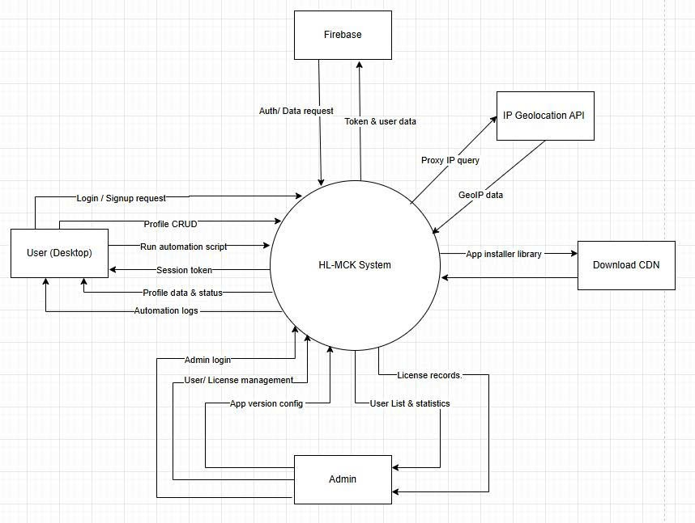

1.2 Main Workflows
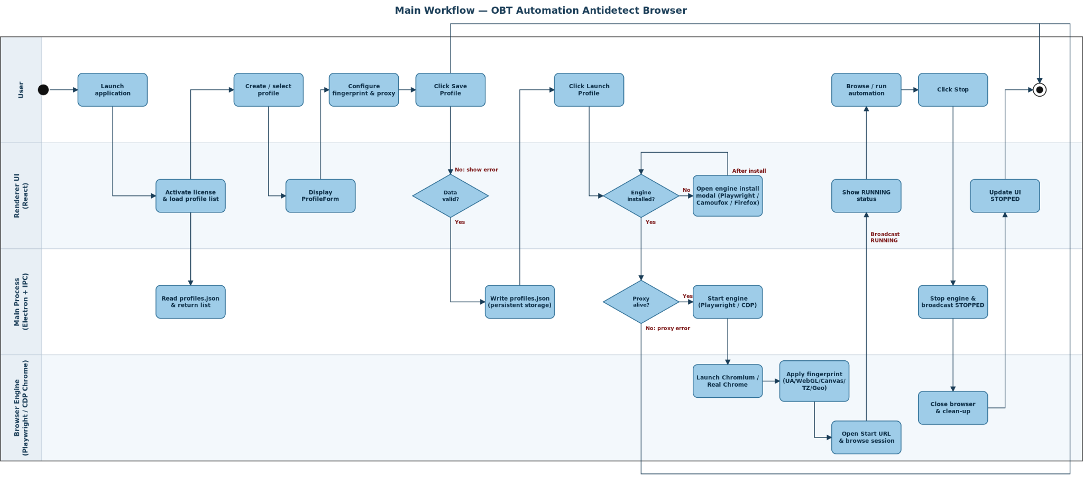

1.3 User Requirements

1.3.1 Web Application

1.3.1.1 Actors

# | Actor | Role Type | Description
1 | User | Primary Actor | Anonymous visitor browsing the landing page, downloading the installer, or requesting a free trial key.
2 | Admin | Primary Actor | Administrator managing CMS contents, download links, and traffic analytics.
3 | System Database | Secondary Actors | A central storage system that securely manages user accounts, license keys, and records explicit ethical consents sent from the Web Application.

1.3.1.2 Use Cases (UC)

ID | Use Case | Feature | Use Case Description
UC_01.01 | Sign in | Authentication | Authenticates existing Users or Administrators into the web portal securely using established credentials.
UC_01.02 | Sign up | Authentication | Permits new visitors to register a unified account within the system to access licensing and software downloads.
UC_01.03 | Forgot password | Authentication | Initiates a secure password-recovery workflow via email link or OTP for accounts that have lost access.
UC_01.04 | Agree to EULA & Ethics Policy | Authentication | Requires new users to explicitly consent to the Anti-Abuse and Ethical Use policies prior to completing account registration.
UC_02.01 | Download App | Download | Provides authenticated Users with secure access to download the latest executable binaries of the HL-MCK Desktop Application.
UC_03.01 | Get License Key | License Key | Exposes the User's purchased or assigned software License Keys directly within their personal dashboard post-login.
UC_04.01 | Search User | Manage User | Enables Administrators to quickly locate specific user records
UC_04.02 | View List User | Manage User | Displays a paginated data table to Administrators containing all registered accounts
UC_05.01 | Find license | Manage License | Allows Administrators to query the license database to inspect a specific key's origin
UC_05.02 | Revoke License | Manage License | Empowers Administrators to instantly suspend or permanently invalidate an active license, effectively blocking the associated user's Desktop App.
UC_06.01 | Manage App Version | Configuration | Allows Administrators to upload, version-tag, and publish new releases of the Desktop software to the User download portal.
UC_06.02 | Maintenance mode | Configuration | Allows Administrators to toggle a global system flag that restricts user logins .

1.3.1.3 Use Case Diagrams
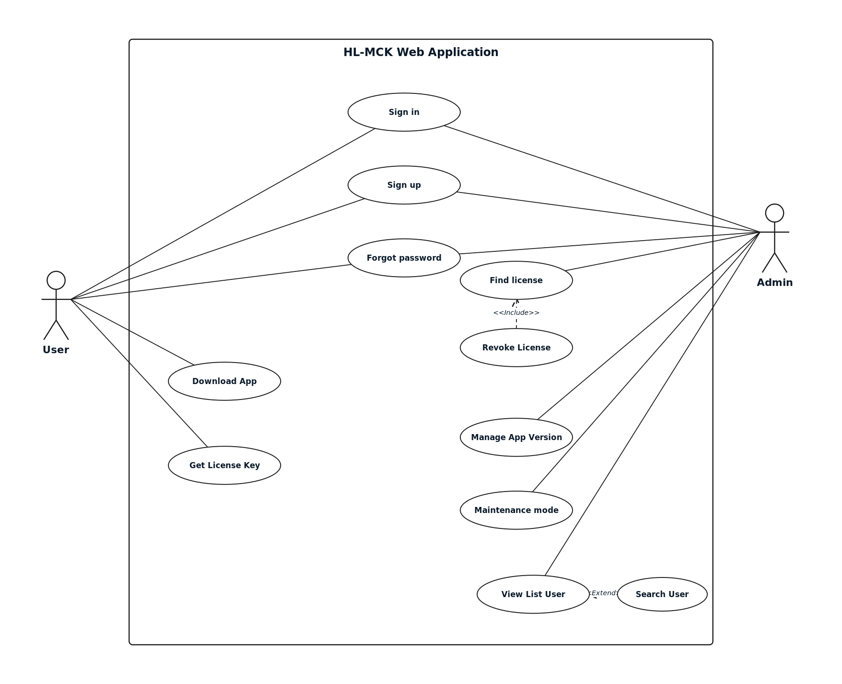

1.3.2 Desktop App

1.3.2.1 Actors

# | Actor | Role Type | Description
1 | User | Primary Actor | Authenticated local operator running the antidetect browser, managing profiles, proxies, and automation tools.
2 | API Client | Primary Actor | External software or developer script driving the browser externally via local REST endpoints.
3 | License Server | Secondary Actor | Remote cloud infrastructure (Firebase) responsible for verifying hardware identifiers, validating subscription orders, and dynamically authorizing tier limits for the local application
4 | Browser Engine | Secondary Actor | Local Playwright/Chromium engine executing isolated DOM environments and processing emulation commands.
5 | Local File System | Secondary Actor | The host machine's operating system layer that securely saves exported audit logs and automation data directly to the user's local hard drive.

1.3.2.2 Use Cases (UC)

ID | Use Case | Feature | Use Case Description
UC_07.01 | Activate License | Activation | Authenticates the user's machine code against the cloud server to unlock software limits and premium features.
UC_08.01 | Create Browser Profile | Profile Management | Allows the user to generate a new anonymous browser environment with customized or random hardware fingerprints.
UC_08.02 | Edit Profile Configuration | Profile Management | Allows the user to modify an existing profile's fingerprint, proxy settings, or execution parameters.
UC_08.03 | Delete Profile | Profile Management | Permanently removes a browser profile and its associated session data from local storage.
UC_08.04 | Launch Profile (Visible Mode) | Profile Management | Start the antidetect Chromium browser with a graphical interface for manual user interaction.
UC_08.05 | Launch Profile (Headless) | Profile Management | Start the browser silently in the background without rendering a UI, typically for automation.
UC_08.06 | Stop Profile | Profile Management | Force-closes an active browser session and saves its current open tabs and state.
UC_08.07 | Add Proxy for Profile | Profile Management | Binds a specific network proxy from the proxy library to a designated profile.
UC_09.01 | Add Proxy | Proxy Management | Allows the user to manually input a single proxy server credential into the global library.
UC_09.02 | Import Proxy | Proxy Management | Allows bulk importing of proxies by parsing a raw text file or clipboard data.
UC_09.03 | Export Proxy | Proxy Management | Exports the current list of saved proxies into a text or CSV format.
UC_09.04 | Check Proxy Connection | Proxy Management | Pings the proxy server to verify its availability, calculate latency (ms), and resolve its geolocation.
UC_09.05 | Rotate IP Proxy | Proxy Management | Triggers the proxy provider's rotation URL to request a fresh IP address for dynamic proxies.
UC_09.06 | Delete Proxy | Proxy Management | Removes a proxy entry from the global library.
UC_09.07 | Edit Proxy | Proxy Management | Modifies the credentials, host, or ports of an existing saved proxy.
UC_10.01 | Create Automation Script | Script Management | Opens the built-in code editor to write a new Javascript automation bot using the Playwright API.
UC_10.02 | Import Script | Script Management | Loads a previously saved .js or .json script file into the software's library.
UC_10.03 | Export Script | Script Management | Saves an existing script to the local computer for sharing or backup.
UC_10.04 | Edit Script | Script Management | Modifies the logic, code, or schedule of an existing script in the library.
UC_10.05 | Run Script on A Profile | Script Management | Executes a chosen automation script against a single designated browser profile.
UC_10.06 | Run Script on Multiple Profiles | Script Management | Executes a chosen script continuously or concurrently across selected multiple profiles (Bulk Run).
UC_10.07 | Pause/Continue Script | Script Management | Temporarily pauses or resumes an ongoing automation script execution on an active profile.
UC_10.08 | Stop a Script | Script Management | Aborts the current automation script execution and shuts down the associated profile instance.
UC_10.09 | View List Task | Script Management | Displays the execution history and the current queue of running/queued automation tasks in the Task Logs.
UC_10.10 | Run a Task | Script Management | Initiates a queued ad-hoc task to begin execution on its designated profile.
UC_10.11 | Run Again a Task | Script Management | Re-queues/restarts a previously completed or failed task history log for a new execution attempt.
UC_10.12 | Delete a Task | Script Management | Removes a specific task log entry from the execution history.
UC_10.13 | Delete All Tasks | Script Management | Clears the entire task history log to free up space.
UC_10.14 | Install Script Module | Script Management | Downloads and installs an external NPM package/library to be required inside automation scripts.
UC_10.15 | Uninstall Script Module | Script Management | Removes an installed NPM package from the script sandbox dependency tree.
UC_11.01 | View System Log | Logging | Displays core application operational logs, errors, and system events internally.
UC_11.02 | View Script Log | Logging | Displays the console.log lines and error traces produced by an executing automation script.
UC_11.03 | Export System Audit Log | Logging | Allows users to securely export historically encrypted records of automation actions for accountability and compliance evidence.
UC_12.01 | View Browser Engine | Browser Engine | Checks the currently installed Chromium/Playwright browser core versions.
UC_12.02 | Install Browser Engine | Browser Engine | Downloads the required browser binaries needed to launch isolated profile containers.
UC_12.03 | Uninstall Browser Engine | Browser Engine | Removes downloaded browser cores to free up hard drive space.
UC_13.01 | Set Theme | Setting | Toggles the application dashboard between dark mode and light mode.
UC_13.02 | Start API Server | Setting | Activates the local Express/REST server on a specified port to accept external API calls.
UC_13.03 | Stop API Server | Setting | Shuts down the local REST server, blocking external programmatic access to the application.
UC_14.01 | API: List All Profiles | API Profiles | Retrieves a JSON array of all existing browser profiles and their metadata via HTTP GET.
UC_14.02 | API: Create Profile | API Profiles | Generates a new profile programmatically via HTTP POST with a payload configuration.
UC_14.03 | API: Edit Profile | API Profiles | Updates a profile's settings configuration programmatically via HTTP PUT.
UC_14.04 | API: Delete Profile | API Profiles | Deletes a specified profile from the system via HTTP DELETE.
UC_15.01 | Launch Browser for a Profile | API Browser Control | Starts the browser process for a profile from a remote HTTP POST trigger.
UC_15.02 | Close Browser for a Profile | API Browser Control | Gracefully shuts down a remote-controlled browser process via HTTP POST.
UC_15.03 | Check if browser is running for a Profile | API Browser Control | Polls the system to verify if a specified profile process is currently running via HTTP GET.
UC_16.01 | Navigate to a URL | API Browser Actions | Instructs the active browser to go to a highly specific URL utilizing the Playwright Page API.
UC_16.02 | Reload the current Page | API Browser Actions | Forces the running isolated browser to refresh its active tab.
UC_16.03 | Navigate Back | API Browser Actions | Navigates the running browser context backward in its session history.
UC_16.04 | Navigate Forward | API Browser Actions | Navigates the running browser context forward in its session history.
UC_16.05 | Get full page HTML content | API Browser Actions | Extracts and returns the entire innerHTML structure of the remote browser's current active DOM.
UC_17.01 | List task , optionally filtered by profileId | API TASK | Fetches the automation task history and queue, filterable by profile ID.
UC_17.02 | Create a new automation task | API TASK | Injects a raw javascript payload into the queue as a disposable ad-hoc task.
UC_17.03 | Enqueue a task for execution | API TASK | Triggers a stored script or queued payload to immediately start running on the browser engine.
UC_17.04 | Cancel a queue or running task | API TASK | Force-stops an actively running task or removes a pending task from the execution pipeline.
UC_17.05 | Delete a task record | API TASK | Deletes an execution history task record algorithmically.
UC_18.01 | List all Proxy | API Proxy | Returns the full list of saved HTTP/SOCKS proxies.
UC_18.02 | Create a new Proxy | API Proxy | Automatically adds a proxy configuration into the library database via HTTP.
UC_18.03 | Update a Proxy | API Proxy | Update a current proxy via HTTP PUT
UC_18.04 | Delete a Proxy | API Proxy | Delete a current proxy via HTTP DELETE
UC_19.01 | List all script | API Script | Retrieves the database of saved automation Javascript templates.
UC_19.02 | Create new script | API Script | Programmatically saves a new automation script template into the system's local storage.
UC_19.03 | Update a script | API Script | Edits the properties and logic of a saved script via HTTP.
UC_19.04 | Delete a script and cancel its cron job | API Script | Removes a script template and halts its associated scheduled cron jobs.
UC_20.01 | Generate a fingerprint ( not saved) | API fingerprint | Returns a randomly generated hardware spoofing object without attaching it to any Profile.
UC_20.02 | Generate and save a fingerprint for a profile | API fingerprint | Generates and immediately commits a new hardware spoofing signature to a targeted Profile.
UC_21.01 | Server health check | API health | Responds with 200 OK to inform external load balancers/controllers that the local server is alive.

1.3.2.3 Use Case Diagrams
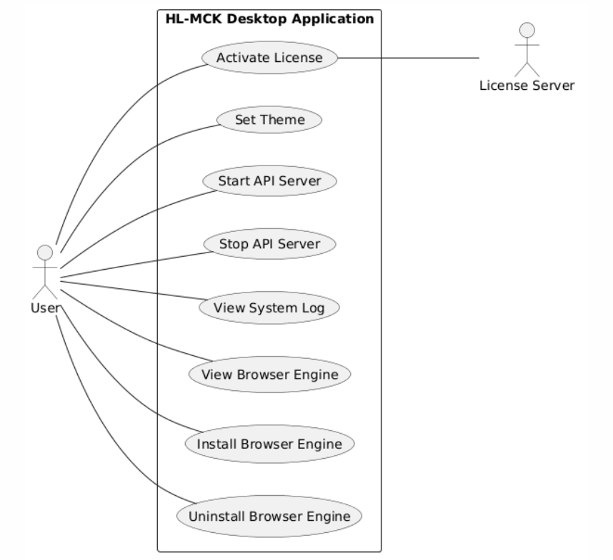
Figure 1.3.2.3.1 System Core & Activation

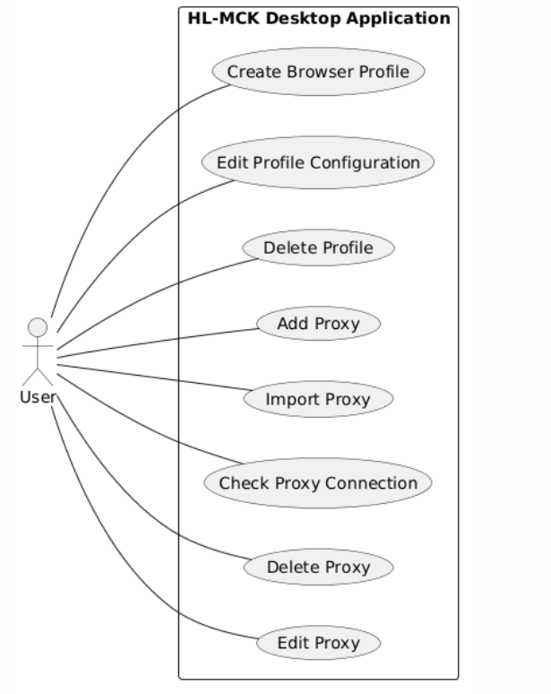
Figure 1.3.2.3.2 Profile & Proxy Management via UI
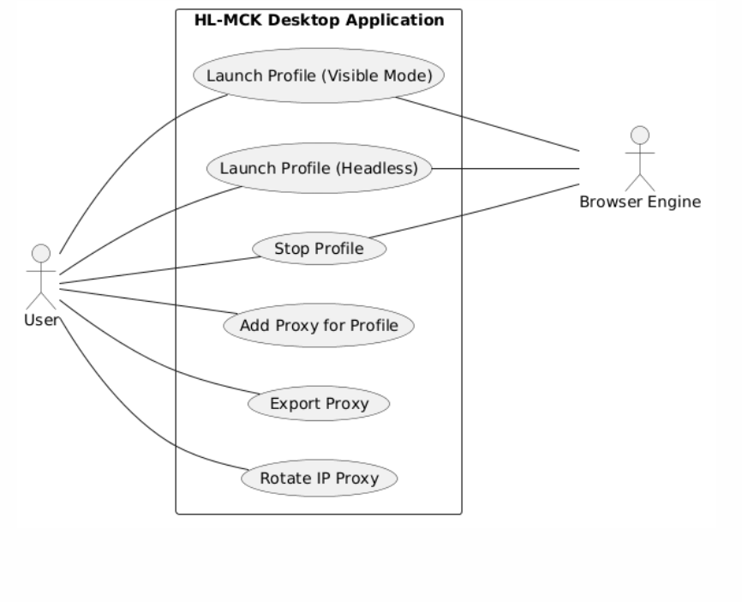

Figure 1.3.2.3.3 Execution & Browser Launch (UI)
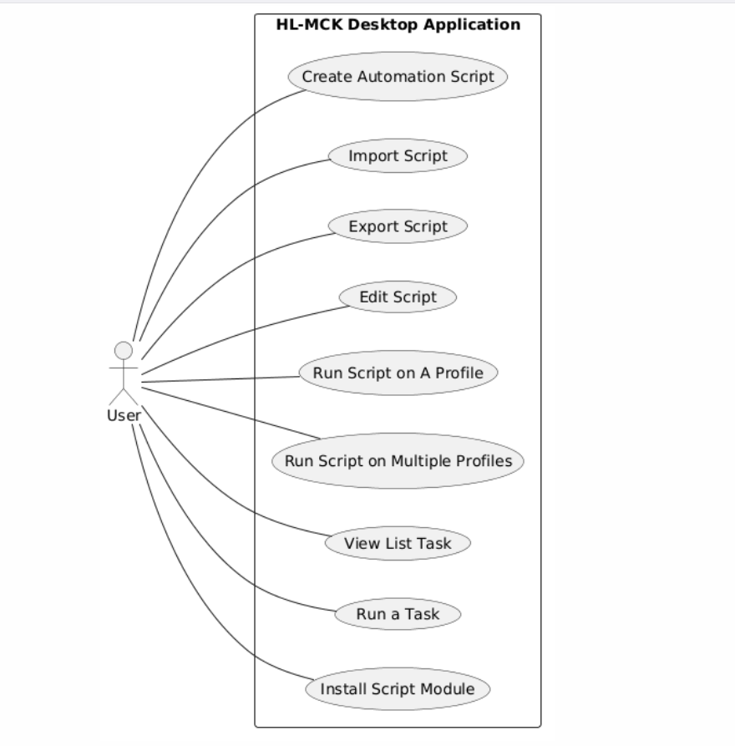
Figure 1.3.2.3.4 Script & Task Configuration (UI)
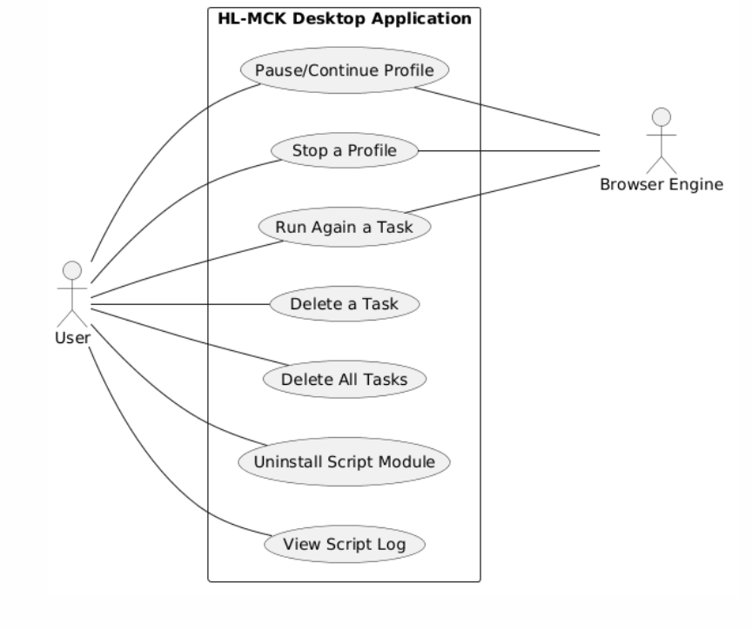
Figure 1.3.2.3.5 Advanced Automation Management (UI)
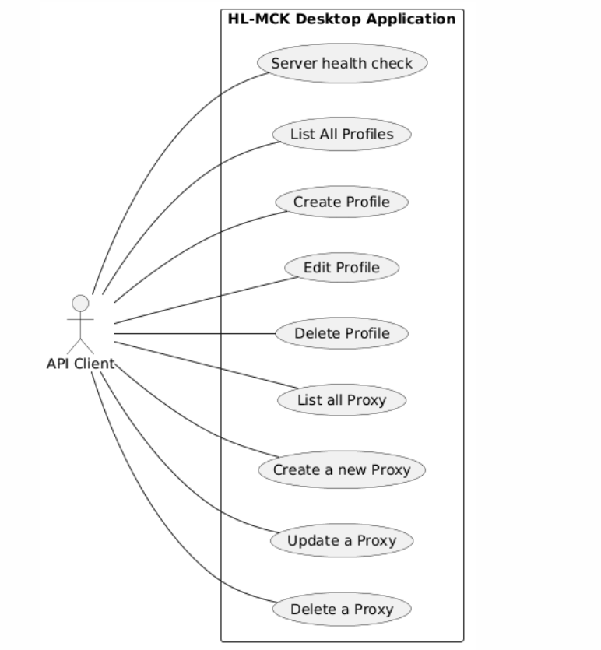
Figure 1.3.2.3.6 Remote API Client (Profile, Proxy & Health)
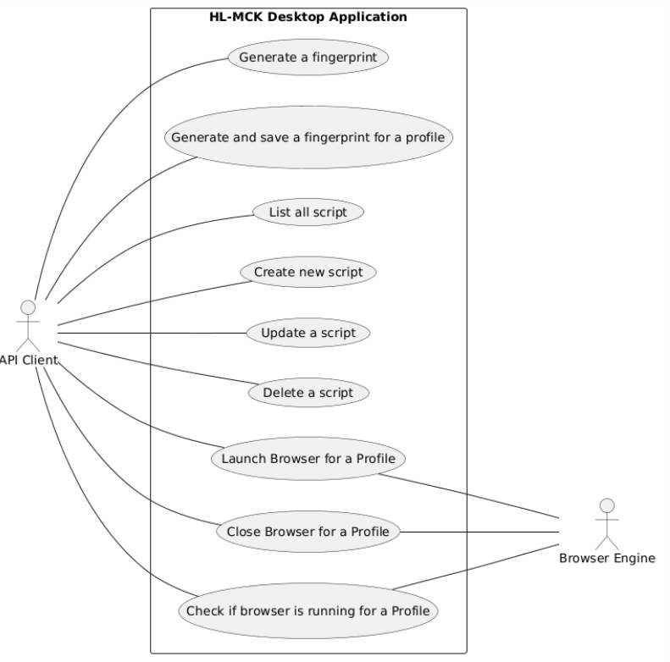
Figure 1.3.2.3.7 Remote API Client (Scripts, Fingerprint & Automation Flow)
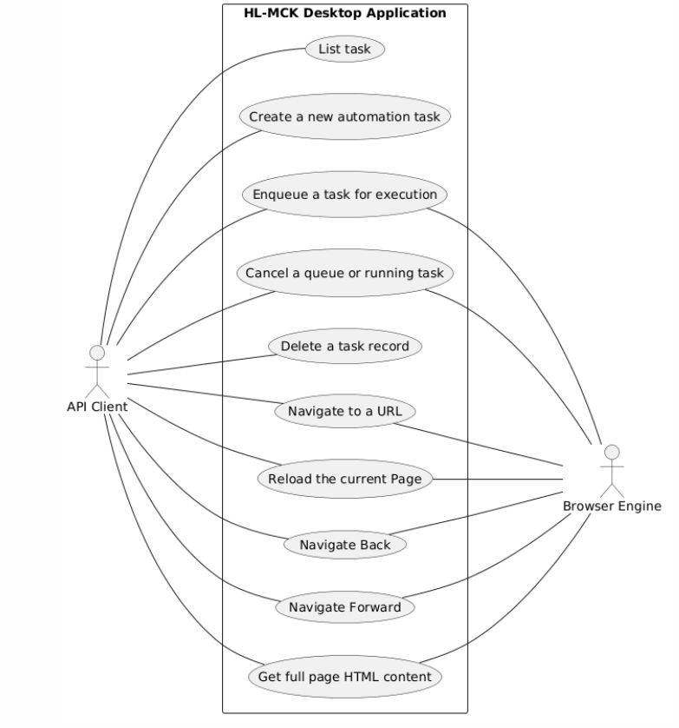
Figure 1.3.2.3.8 Remote API Client (Task Execution & Live Action Control)

1.4 System Functionalities

1.4.1 Screens Flow for Desktop App

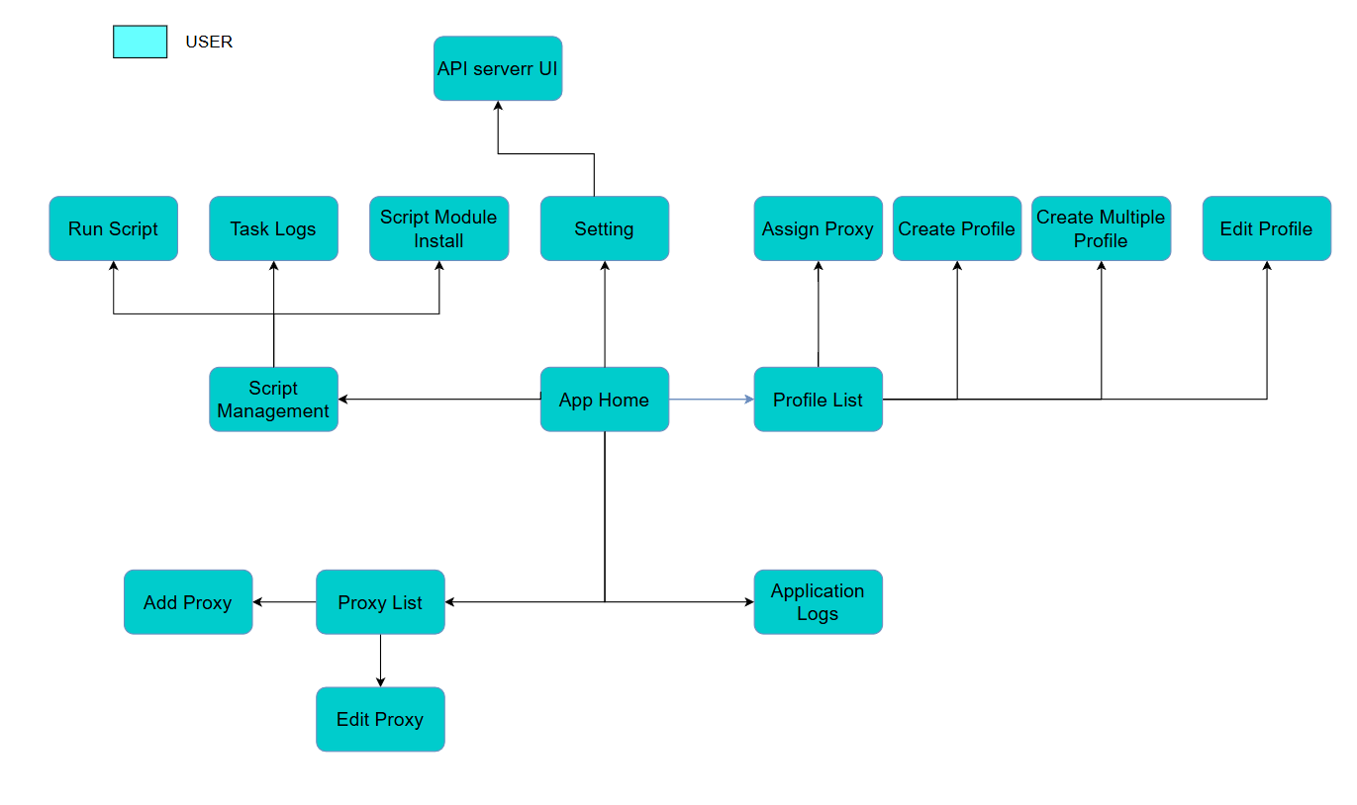

1.4.2 Screens Flow for Web
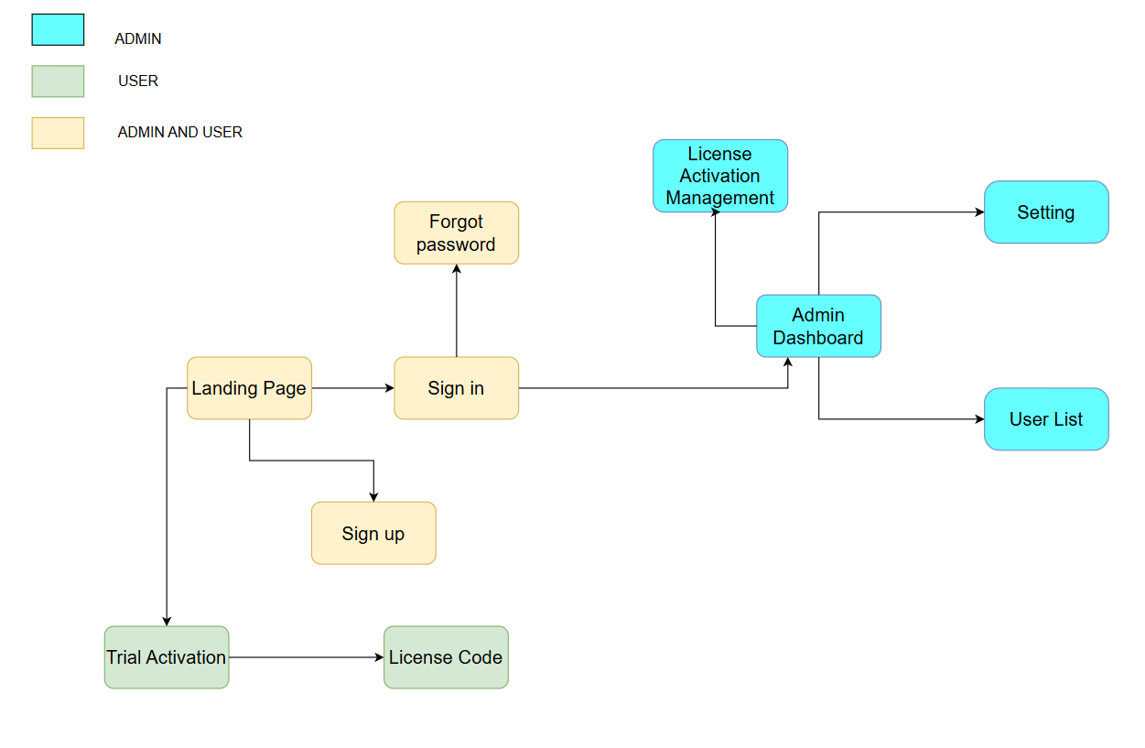

1.4.3 Screen Authorization

# | Screen | User | Admin
1 | App Home | X
2 | Profile List | X
3 | Assign Proxy | X
4 | Create Profile | X
5 | Create Multiple Profile | X
6 | Edit Profile | X
7 | Proxy List | X
8 | Edit Proxy | X
9 | Add Proxy | X
10 | Script Management | X
11 | Run Script | X
12 | Task Logs | X
13 | Script Module Install | X
14 | Application Logs | X
15 | Setting | X
16 | API Server UI | X
17 | Landing Page | X | X
18 | Sign In | X | X
19 | Sign Up | X | X
20 | Forgot password | X | X
21 | Trial Activation | X
22 | License Code | X
23 | Admin Dashboard |  | X
24 | Setting |  | X
25 | License Activation Management |  | X
26 | User List |  | X

1.4.4 Non-UI Functions
# | Feature | System Function | Description
1 | Local REST API | REST API Server | A local backend service hosted by the application (using Express/Fastify) that exposes HTTP endpoints. It allows external automation scripts and developer tools to programmatically create, update, delete, and launch profiles without interacting with the GUI.
2 | Automated Task Scheduler | Automation Cron Job | A background batch service (using node-cron) that monitors user-defined schedules. It continuously evaluates time expressions and automatically triggers the launch of specific profiles or scripts when conditions are met.
3 | Proxy Validation | Proxy Checker Service | A background network utility that connects to HTTP/HTTPS or SOCKS5 proxies. It validates connectivity, latency, and geographic location, returning status internally before launching a browser.
4 | Machine Identification | Machine ID Generator | A non-UI hardware scanning service that extracts system components (e.g., motherboard, CPU, MAC address) to generate a unique "Machine Code" used for license validation with the HL-MCK server.
5 | Browser Orchestration | Browser Manager Service | A core service that manages browser processes. It handles downloading, installing, and running customized Chromium/Firefox instances via Playwright or Chrome DevTools Protocol (CDP).
6 | Data Persistence | Local SQLite Storage | A local database layer using better-sqlite3 to handle async read/write operations. It stores profiles, fingerprints, and settings securely on the user's machine without cloud dependency.

1.5 Entity Relationship Diagram

1.5.1 ERD of Web

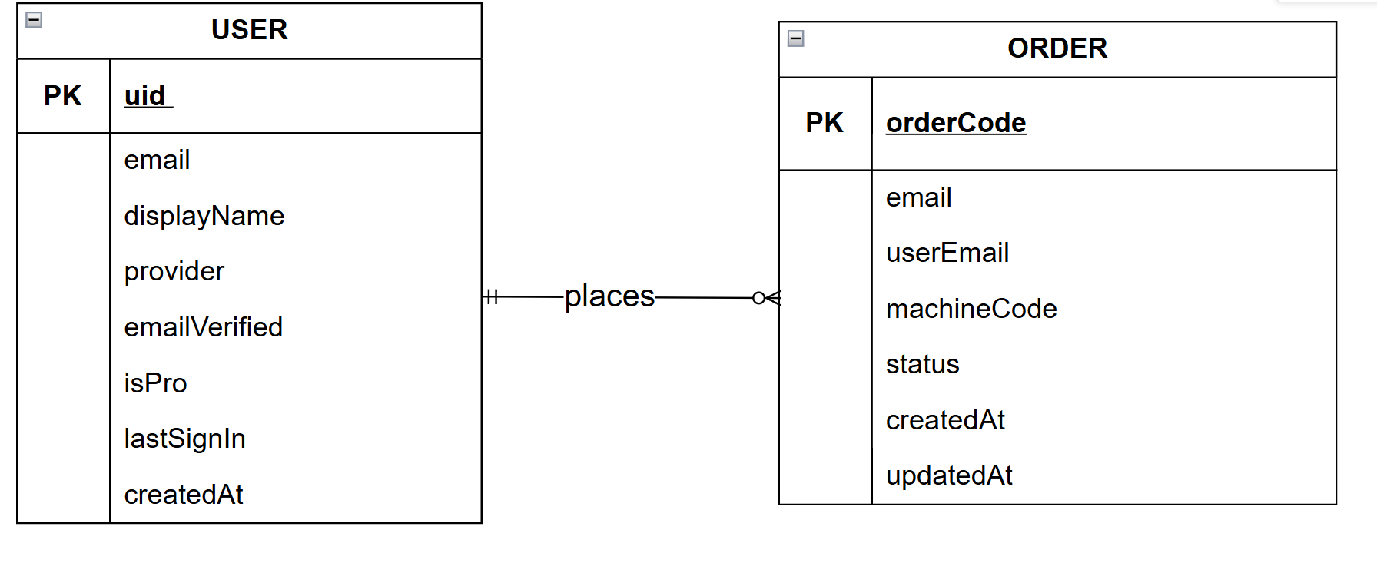
Entities Description

# | Entity | Description
1 | USER | Manages the account information of customers accessing the web dashboard.
2 | ORDER | Manages purchase history, transactions, and License Key distribution.

1.5.2 ERD of Desktop App

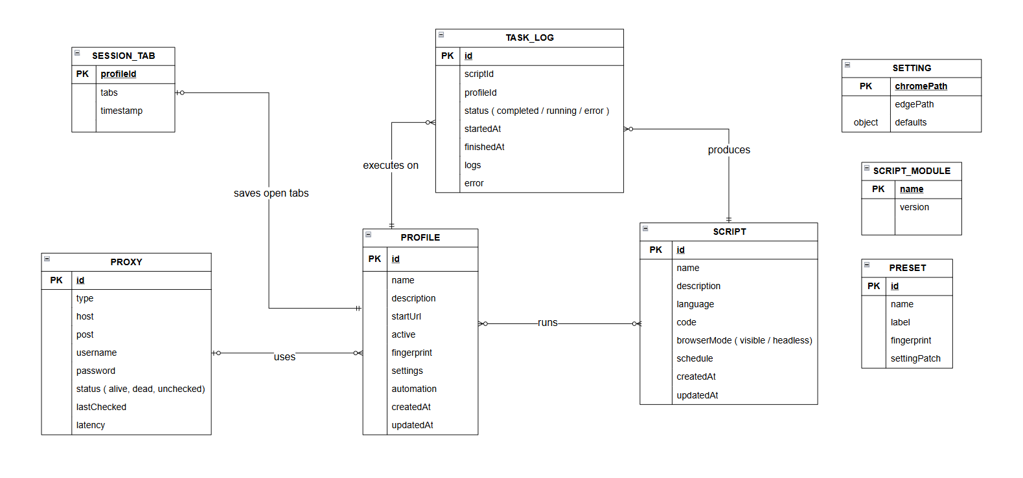

Entities Description

# | Entity | Description
1 | PROFILE | Anonymous Browser Environments (Antidetect Containers) — The heart of the entire system. Encapsulates all digital fingerprint data (WebGL, Canvas, WebRTC, etc.), hardware execution settings (RAM, CPU), background browser engine configurations, assigned proxies, and automation workflows. Ensures that every launched Profile acts as a completely independent web browsing identity
2 | PROXY | A library of IP addresses and network routing nodes.Stores server addresses, ports, protocol formats (HTTP/SOCKS), and authentication credentials. PROFILES bind to entries in this list to route network traffic, thereby masking internal IPs and spoofing geographical locations. Also provides connection latency checking features.
3 | SCRIPT | A repository for Automation Tasks and toolings.Stores executable logic source code (Javascript/bot scripts), execution schedules (cron jobs), and browser launch modes (headless or visible) to replace manual human interactions (e.g., auto-surfing, seeding, or data crawling).
4 | TASK LOG | An execution history ledger for scripts/bots.Acts as an intermediate Junction table. It records the historical transaction of Script A running on Profile B—when it started, how long it took, and if it encountered any errors (error data). This is extremely critical for debugging and outputting statistical tool reports.
5 | SESSION_TAB | Storage snapshots for the last opened browser windows.When a user closes an antidetect Profile, the list of currently opened websites (URLs) is intercepted and saved here. The next time the profile is launched, the app reads this table to restore exactly the same tabs (Restore Previous Session feature).
6 | PRESET | Profile parameter templates / generic molds.Instead of configuring hardware details 10 times for 10 separate Profiles, the user sets it up once and saves it to the Presets array. Later, they can quickly clone this Template to spawn dozens of identical new Profiles to save setup time.
7 | SCRIPT MODULE | Dependency configurations for external programming libraries (NPM Package Sandbox). Dedicated to technical developers. Automation scripts sometimes need to import external libraries from the internet. This entity (via an isolated package.json) helps install, uninstall, and control module versions for the bots to utilize safely.
8 | SETTING | The Global Dashboard configuration file. Stores root settings for the software framework (independent of any specific Profile). For example, configuring the exact executable Path to wrap and launch the native Chrome browser core located on the local hard drive.

2. Use Case Specifications

2.1 Activation

2.1.1 Activate License

UC Id & name | UC-07.01 : Activate License
Primary Actors | User | Secondary Actors | License Server
Created by | manhpthe172481 | Date created | 22-03-2026
Description | As an Unlicensed User, I want to authenticate my machine using a valid License Key so that I can bypass software locks and access premium automation features based on my subscription plan.
Preconditions | PRE_01: The HL-MCK Desktop Application is successfully installed and opened on the local machine.  PRE_02: The application is currently in an Unlicensed or Expired state.  PRE_03: The system has successfully generated a unique Machine Code based on the user's hardware.  PRE_04: Host machine has an active internet connection to reach the remote License Server.
Postconditions | POST_01: The License Key is validated and its state is cached locally.  POST_02: The application unlocks specific features and tabs according to the purchased License Plan.  POST_03: The application transitions to the Licensed state and redirects the user to the main Dashboard.
Normal Sequence/Flow | 1. System displays the "Activation Required" modal upon booting up, showing the unique Machine Code.  2. User copies the Machine Code and acquires a valid License Key from the vendor.  3. User pastes the acquired License Key into the input field.  4. User clicks the "Activate License" button.  5. System securely transmits the License Key and Machine Code to the License Verification Service.  6. Verification succeeds -> System stores the Licensed state locally and fully unlocks the application.
Alternative Sequences/Flows | 1A. Activate via Settings Menu  1. In the initial modal, User clicks "Continue with free plan".  2. System navigates to the main operational layout in Free Mode.  3. User navigates to the "Settings" tab on the left sidebar.  4. System displays the License configuration card showing "Not licensed".  5. User pastes the License Key into the Settings input field and clicks "Activate".  6. The sequence merges into Normal Flow step 5.
Exception Flows | 4A. Empty Input Field  1. At step 4, if the input field is blank.  2. System highlights the field and displays: "Vui lòng nhập license key."  3. User is prompted to enter a key; the sequence resumes.  5A. Network Timeout / No Internet  1. At step 5, if the local network is unreachable or the server is down.  2. System displays: "Đã xảy ra lỗi. Thử lại sau."  3. User manually checks network config; sequence resumes at step 4.  6A. Invalid or Hardware Mismatched Key  1. At step 6, if the verification service determines the key is invalid or registered to a different Machine.  2. System aborts activation and displays: "License key không hợp lệ với máy này."  3. The sequence resumes at step 3.
Business Rules | BR-01, BR-02, BR-03

2.2 Browser Profile Management

2.2.1 Create Browser Profile

UC Id & name | UC_08.01 : Create Browser Profile
Primary Actors | User | Secondary Actors | None
Created by | manhpthe172481 | Date created | 24-03-2026
Description | Allows the user to generate a new anonymous browser environment with customized or random hardware fingerprints.
Preconditions | PRE_01: Application is launched.
Postconditions | POST_01: The new entity is permanently stored in the local file system.
Normal Sequence/Flow | 1. User clicks the 'Create/Add' button in the dashboard.  2. System opens the configuration form modal.  3. User fills in the necessary parameters.  4. User clicks Save.  5. System validates inputs and writes data asynchronously to local JSON storage.  6. System refreshes the UI list.
Alternative Sequences/Flows | None
Exception Flows | 5A. Empty Required Fields  1. System highlights invalid inputs and blocks submission.  5B. File I/O Error  1. Storage is locked/readonly resulting in write failure.
Business Rules | BR-04, BR-05,BR-18

2.2.2 Edit Browser Profile

.

UC Id & name | UC_08.02 : Edit Profile Configuration
Primary Actors | User | Secondary Actors | None
Created by | manhpthe172481 | Date created | 24-03-2026
Description | Allows the user to modify an existing profile's fingerprint, proxy settings, or execution parameters.
Preconditions | PRE_01: Application is launched.
Postconditions | POST_01: Entity is mutated and synced linearly.
Normal Sequence/Flow | 1. User clicks the Edit icon on an existing record.  2. System loads current properties into the form.  3. User modifies parameters and submits.  4. System overwrites the targeted JSON entry.  5. UI refreshes.
Alternative Sequences/Flows | None
Exception Flows | 4A. Corrupted Entry  1. Base entry is missing. System alerts user.
Business Rules | BR-04, BR-05

2.2.3 Delete Browser Profile

UC Id & name | UC_08.03 : Delete Profile
Primary Actors | User | Secondary Actors | None
Created by | manhpthe172481 | Date created | 24-03-2026
Description | Permanently removes a browser profile and its associated session data from local storage.
Preconditions | PRE_01: Application is launched.
Postconditions | POST_01: Selected item is permanently expunged from the disk.
Normal Sequence/Flow | 1. User selects the target item and clicks Delete.  2. System prompts a confirmation dialog.  3. User confirms deletion.  4. System removes the item from the local DB and purges associated resources.  5. UI refreshes.
Alternative Sequences/Flows | None
Exception Flows | 3A. User Cancels  1. User aborts the dialog. No changes made.
Business Rules | BR-04, BR-05

2.2.4 Launch Profile ( Visible)

UC Id & name | UC_08.04 : Launch Profile (Visible Mode)
Primary Actors | User | Secondary Actors | Browser Engine
Created by | manhpthe172481 | Date created | 24-03-2026
Description | Start the antidetect Chromium browser with a graphical interface for manual user interaction.
Preconditions | PRE_01: Application is launched.
Postconditions | POST_01: Browser Window is instantiated securely.
Normal Sequence/Flow | 1. Action is triggered on a specific Profile UUID.  2. System calculates engine flags, fingerprint parameters, and proxy strings.  3. System spawns the isolated Chromium/Playwright process.  4. System binds bidirectional IPC sockets for CDP monitoring.  5. State transitions to RUNNING.
Alternative Sequences/Flows | None
Exception Flows | 2A. Browser Not Installed  1. System halts and prompts user to Download Engine.  3A. Port/Resource Collision  1. Engine fails to bind. App gracefully kills zombie processes.
Business Rules | BR-10, BR-11

2.2.5 Launch Headless Profile

UC Id & name | UC_08.05 : Launch Profile (Headless)
Primary Actors | User | Secondary Actors | Browser Engine
Created by | manhpthe172481 | Date created | 24-03-2026
Description | Start the browser silently in the background without rendering a UI, typically for automation.
Preconditions | PRE_01: Application is launched.
Postconditions | POST_01: Browser Window is instantiated securely.
Normal Sequence/Flow | 1. Action is triggered on a specific Profile UUID.  2. System calculates engine flags, fingerprint parameters, and proxy strings.  3. System spawns the isolated Chromium/Playwright process.  4. System binds bidirectional IPC sockets for CDP monitoring.  5. State transitions to RUNNING.
Alternative Sequences/Flows | None
Exception Flows | 2A. Browser Not Installed  1. System halts and prompts user to Download Engine.  3A. Port/Resource Collision  1. Engine fails to bind. App gracefully kills zombie processes.
Business Rules | BR-10, BR-11

2.2.7 Stop Profile

UC Id & name | UC_08.06 : Stop Profile
Primary Actors | User | Secondary Actors | Browser Engine
Created by | manhpthe172481 | Date created | 24-03-2026
Description | Force-closes an active browser session and saves its current open tabs and state.
Preconditions | PRE_01: Application is launched.
Postconditions | POST_01: Browser Window is instantiated securely.
Normal Sequence/Flow | 1. Action is triggered on a specific Profile UUID.  2. System calculates engine flags, fingerprint parameters, and proxy strings.  3. System spawns the isolated Chromium/Playwright process.  4. System binds bidirectional IPC sockets for CDP monitoring.  5. State transitions to RUNNING.
Alternative Sequences/Flows | None
Exception Flows | 2A. Browser Not Installed  1. System halts and prompts user to Download Engine.  3A. Port/Resource Collision  1. Engine fails to bind. App gracefully kills zombie processes.
Business Rules | BR-10, BR-11

2.2.8 Add Proxy for Profile

UC Id & name | UC_08.07 : Add Proxy for Profile
Primary Actors | User | Secondary Actors | None
Created by | manhpthe172481 | Date created | 24-03-2026
Description | Binds a specific network proxy from the proxy library to a designated profile.
Preconditions | PRE_01: Application is launched.
Postconditions | POST_01: The new entity is permanently stored in the local file system.
Normal Sequence/Flow | 1. User clicks the 'Create/Add' button in the dashboard.  2. System opens the configuration form modal.  3. User fills in the necessary parameters.  4. User clicks Save.  5. System validates inputs and writes data asynchronously to local JSON storage.  6. System refreshes the UI list.
Alternative Sequences/Flows | None
Exception Flows | 5A. Empty Required Fields  1. System highlights invalid inputs and blocks submission.  5B. File I/O Error  1. Storage is locked/readonly resulting in write failure.
Business Rules | BR-04, BR-05

2.3 Proxy Management

2.3.1 Add Proxy

UC Id & name | UC_09.01 : Add Proxy
Primary Actors | User | Secondary Actors | None
Created by | manhpthe172481 | Date created | 24-03-2026
Description | Allows the user to manually input a single proxy server credential into the global library.
Preconditions | PRE_01: Application is launched.
Postconditions | POST_01: The new entity is permanently stored in the local file system.
Normal Sequence/Flow | 1. User clicks the 'Create/Add' button in the dashboard.  2. System opens the configuration form modal.  3. User fills in the necessary parameters.  4. User clicks Save.  5. System validates inputs and writes data asynchronously to local JSON storage.  6. System refreshes the UI list.
Alternative Sequences/Flows | None
Exception Flows | 5A. Empty Required Fields  1. System highlights invalid inputs and blocks submission.  5B. File I/O Error  1. Storage is locked/readonly resulting in write failure.
Business Rules | BR-07, BR-08, BR-09

2.3.2 Import Proxy

UC Id & name | UC_09.02 : Import Proxy
Primary Actors | User | Secondary Actors | None
Created by | manhpthe172481 | Date created | 24-03-2026
Description | Allows bulk importing of proxies by parsing a raw text file or clipboard data.
Preconditions | PRE_01: Application is launched.
Postconditions | POST_01: Application state reflects the requested action.
Normal Sequence/Flow | 1. User initiates the UI interaction.  2. System computes the logic or executes the command.  3. System updates application state and reflects UI feedback.
Alternative Sequences/Flows | None
Exception Flows | None
Business Rules | BR-07, BR-08, BR-09

2.3.3 Export Proxy

UC Id & name | UC_09.03 : Export Proxy
Primary Actors | User | Secondary Actors | None
Created by | manhpthe172481 | Date created | 24-03-2026
Description | Exports the current list of saved proxies into a text or CSV format.
Preconditions | PRE_01: Application is launched.
Postconditions | POST_01: Application state reflects the requested action.
Normal Sequence/Flow | 1. User initiates the UI interaction.  2. System computes the logic or executes the command.  3. System updates application state and reflects UI feedback.
Alternative Sequences/Flows | None
Exception Flows | None
Business Rules | BR-07, BR-08, BR-09

2.3.4 Check Proxy Connection

UC Id & name | UC_09.04 : Check Proxy Connection
Primary Actors | User | Secondary Actors | None
Created by | manhpthe172481 | Date created | 24-03-2026
Description | Pings the proxy server to verify its availability, calculate latency (ms), and resolve its geolocation.
Preconditions | PRE_01: Application is launched.
Postconditions | POST_01: Application state reflects the requested action.
Normal Sequence/Flow | 1. User initiates the UI interaction.  2. System computes the logic or executes the command.  3. System updates application state and reflects UI feedback.
Alternative Sequences/Flows | None
Exception Flows | None
Business Rules | BR-07, BR-08, BR-09

2.3.5 Rotate IP Proxy

UC Id & name | UC_09.05 : Rotate IP Proxy
Primary Actors | User | Secondary Actors | None
Created by | manhpthe172481 | Date created | 24-03-2026
Description | Triggers the proxy provider's rotation URL to request a fresh IP address for dynamic proxies.
Preconditions | PRE_01: Application is launched.
Postconditions | POST_01: Application state reflects the requested action.
Normal Sequence/Flow | 1. User initiates the UI interaction.  2. System computes the logic or executes the command.  3. System updates application state and reflects UI feedback.
Alternative Sequences/Flows | None
Exception Flows | None
Business Rules | BR-07, BR-08, BR-09

2.3.6 Delete Proxy

UC Id & name | UC_09.06 : Delete Proxy
Primary Actors | User | Secondary Actors | None
Created by | manhpthe172481 | Date created | 24-03-2026
Description | Removes a proxy entry from the global library.
Preconditions | PRE_01: Application is launched.
Postconditions | POST_01: Selected item is permanently expunged from the disk.
Normal Sequence/Flow | 1. User selects the target item and clicks Delete.  2. System prompts a confirmation dialog.  3. User confirms deletion.  4. System removes the item from the local DB and purges associated resources.  5. UI refreshes.
Alternative Sequences/Flows | None
Exception Flows | 3A. User Cancels  1. User aborts the dialog. No changes made.
Business Rules | BR-07, BR-08, BR-09

2.3.7 Edit Proxy

UC Id & name | UC_09.07 : Edit Proxy
Primary Actors | User | Secondary Actors | None
Created by | manhpthe172481 | Date created | 24-03-2026
Description | Modifies the credentials, host, or ports of an existing saved proxy.
Preconditions | PRE_01: Application is launched.
Postconditions | POST_01: Entity is mutated and synced linearly.
Normal Sequence/Flow | 1. User clicks the Edit icon on an existing record.  2. System loads current properties into the form.  3. User modifies parameters and submits.  4. System overwrites the targeted JSON entry.  5. UI refreshes.
Alternative Sequences/Flows | None
Exception Flows | 4A. Corrupted Entry  1. Base entry is missing. System alerts user.
Business Rules | BR-07, BR-08, BR-09

2.4 Script Management

2.4.1 Create Automation Script

UC Id & name | UC_10.01 : Create Automation Script
Primary Actors | User | Secondary Actors | Browser Engine
Created by | manhpthe172481 | Date created | 24-03-2026
Description | Opens the built-in code editor to write a new Javascript automation bot using the Playwright API.
Preconditions | PRE_01: Application is launched.
Postconditions | POST_01: The new entity is permanently stored in the local file system.
Normal Sequence/Flow | 1. User clicks the 'Create/Add' button in the dashboard.  2. System opens the configuration form modal.  3. User fills in the necessary parameters.  4. User clicks Save.  5. System validates inputs and writes data asynchronously to local JSON storage.  6. System refreshes the UI list.
Alternative Sequences/Flows | None
Exception Flows | 5A. Empty Required Fields  1. System highlights invalid inputs and blocks submission.  5B. File I/O Error  1. Storage is locked/readonly resulting in write failure.
Business Rules | BR-12, BR-13, BR-14, BR-15

2.4.2 Import Script

UC Id & name | UC_10.02 : Import Script
Primary Actors | User | Secondary Actors | Browser Engine
Created by | manhpthe172481 | Date created | 24-03-2026
Description | Loads a previously saved .js or .json script file into the software's library.
Preconditions | PRE_01: Application is launched.
Postconditions | POST_01: Task logic is processed against the DOM.
Normal Sequence/Flow | 1. Action is dispatched for the target Task/Profile.  2. System injects the JS payload into the target Playwright Context.  3. Script runs synchronously/asynchronously reporting metrics.  4. System streams output to Task Logs in realtime.  5. Context evaluates completion state.
Alternative Sequences/Flows | None
Exception Flows | 3A. Unhandled Script Error  1. Script throws undefined exception. System catches and marks Task as FAILED.
Business Rules | BR-12, BR-13, BR-14, BR-15

2.4.3 Export Script

UC Id & name | UC_10.03 : Export Script
Primary Actors | User | Secondary Actors | Browser Engine
Created by | manhpthe172481 | Date created | 24-03-2026
Description | Saves an existing script to the local computer for sharing or backup.
Preconditions | PRE_01: Application is launched.
Postconditions | POST_01: Task logic is processed against the DOM.
Normal Sequence/Flow | 1. Action is dispatched for the target Task/Profile.  2. System injects the JS payload into the target Playwright Context.  3. Script runs synchronously/asynchronously reporting metrics.  4. System streams output to Task Logs in realtime.  5. Context evaluates completion state.
Alternative Sequences/Flows | None
Exception Flows | 3A. Unhandled Script Error  1. Script throws undefined exception. System catches and marks Task as FAILED.
Business Rules | BR-12, BR-13, BR-14, BR-15

2.4.4 Edit Script

UC Id & name | UC_10.04 : Edit Script
Primary Actors | User | Secondary Actors | Browser Engine
Created by | manhpthe172481 | Date created | 24-03-2026
Description | Modifies the logic, code, or schedule of an existing script in the library.
Preconditions | PRE_01: Application is launched.
Postconditions | POST_01: Entity is mutated and synced linearly.
Normal Sequence/Flow | 1. User clicks the Edit icon on an existing record.  2. System loads current properties into the form.  3. User modifies parameters and submits.  4. System overwrites the targeted JSON entry.  5. UI refreshes.
Alternative Sequences/Flows | None
Exception Flows | 4A. Corrupted Entry  1. Base entry is missing. System alerts user.
Business Rules | BR-12, BR-13, BR-14, BR-15

2.4.5 Run Script on a Profile

UC Id & name | UC_10.05 : Run Script on A Profile
Primary Actors | User | Secondary Actors | Browser Engine
Created by | manhpthe172481 | Date created | 24-03-2026
Description | Executes a chosen automation script against a single designated browser profile.
Preconditions | PRE_01: Application is launched.
Postconditions | POST_01: Task logic is processed against the DOM.
Normal Sequence/Flow | 1. Action is dispatched for the target Task/Profile.  2. System injects the JS payload into the target Playwright Context.  3. Script runs synchronously/asynchronously reporting metrics.  4. System streams output to Task Logs in realtime.  5. Context evaluates completion state.
Alternative Sequences/Flows | None
Exception Flows | 3A. Unhandled Script Error  1. Script throws undefined exception. System catches and marks Task as FAILED.
Business Rules | BR-12, BR-13, BR-14, BR-15,BR-16,BR-17

2.4.6 Run Script on multiple Profiles

UC Id & name | UC_10.06 : Run Script on Multiple Profiles
Primary Actors | User | Secondary Actors | Browser Engine
Created by | manhpthe172481 | Date created | 24-03-2026
Description | Executes a chosen script continuously or concurrently across selected multiple profiles (Bulk Run).
Preconditions | PRE_01: Application is launched.
Postconditions | POST_01: Task logic is processed against the DOM.
Normal Sequence/Flow | 1. Action is dispatched for the target Task/Profile.  2. System injects the JS payload into the target Playwright Context.  3. Script runs synchronously/asynchronously reporting metrics.  4. System streams output to Task Logs in realtime.  5. Context evaluates completion state.
Alternative Sequences/Flows | None
Exception Flows | 3A. Unhandled Script Error  1. Script throws undefined exception. System catches and marks Task as FAILED.
Business Rules | BR-12, BR-13, BR-14, BR-15,BR-16,BR-17

2.4.7 Pause / Continue Script

UC Id & name | UC_10.07 : Pause/Continue Profile
Primary Actors | User | Secondary Actors | Browser Engine
Created by | manhpthe172481 | Date created | 24-03-2026
Description | Temporarily pauses or resumes an ongoing automation script execution on an active profile.
Preconditions | PRE_01: Application is launched.
Postconditions | POST_01: Task logic is processed against the DOM.
Normal Sequence/Flow | 1. Action is dispatched for the target Task/Profile.  2. System injects the JS payload into the target Playwright Context.  3. Script runs synchronously/asynchronously reporting metrics.  4. System streams output to Task Logs in realtime.  5. Context evaluates completion state.
Alternative Sequences/Flows | None
Exception Flows | 3A. Unhandled Script Error  1. Script throws undefined exception. System catches and marks Task as FAILED.
Business Rules | BR-12, BR-13, BR-14, BR-15

2.4.8 Stop a Script

UC Id & name | UC_10.08 : Stop a Script
Primary Actors | User | Secondary Actors | Browser Engine
Created by | manhpthe172481 | Date created | 24-03-2026
Description | Aborts the current automation script execution and shuts down the associated profile instance.
Preconditions | PRE_01: The HL-MCK Desktop Application is successfully launched and the local context is active.
Postconditions | POST_01: Orchestration script is evaluated directly against the isolated Profile DOM.
Normal Sequence/Flow | 1. Action is dispatched for the target Task/Profile execution queue.  2. System injects the JS payload dynamically into the target Playwright Context.  3. Script runs synchronously/asynchronously reporting step metrics.  4. System streams internal output to logs in realtime.  5. Context evaluates operational completion state.
Alternative Sequences/Flows | None
Exception Flows | 3A. Unhandled Script Error  1. User script throws an undefined exception. System catches gracefully and marks Task status as FAILED.
Business Rules | BR-12, BR-13, BR-14, BR-15

2.4.9 View List Task

UC Id & name | UC_10.09 : View List Task
Primary Actors | User | Secondary Actors | None
Created by | manhpthe172481 | Date created | 24-03-2026
Description | Displays the execution history and the current queue of running/queued automation tasks in the Task Logs.
Preconditions | PRE_01: Application is launched and License is Validated.
Postconditions | POST_01: Task logic is processed against the DOM.
Normal Sequence/Flow | 1. Action is dispatched for the target Task/Profile.  2. System injects the JS payload into the target Playwright Context.  3. Script runs synchronously/asynchronously reporting metrics.  4. System streams output to Task Logs in realtime.  5. Context evaluates completion state.
Alternative Sequences/Flows | None
Exception Flows | 3A. Unhandled Script Error  1. Script throws undefined exception. System catches and marks Task as FAILED.
Business Rules | N/A

2.4.10 Run a task

UC Id & name | UC_10.10 : Run a Task
Primary Actors | User | Secondary Actors | Browser Engine
Created by | manhpthe172481 | Date created | 24-03-2026
Description | Initiates a queued ad-hoc task to begin execution on its designated profile.
Preconditions | PRE_01: The HL-MCK Desktop Application is successfully launched and the local context is active.
Postconditions | POST_01: Orchestration script is evaluated directly against the isolated Profile DOM.
Normal Sequence/Flow | 1. Action is dispatched for the target Task/Profile execution queue.  2. System injects the JS payload dynamically into the target Playwright Context.  3. Script runs synchronously/asynchronously reporting step metrics.  4. System streams internal output to logs in realtime.  5. Context evaluates operational completion state.
Alternative Sequences/Flows | None
Exception Flows | 3A. Unhandled Script Error  1. User script throws an undefined exception. System catches gracefully and marks Task status as FAILED.
Business Rules | BR-12, BR-13, BR-14, BR-15,BR-18

2.4.11 Run again a task

UC Id & name | UC_10.11 : Run Again a Task
Primary Actors | User | Secondary Actors | Browser Engine
Created by | manhpthe172481 | Date created | 24-03-2026
Description | Re-queues/restarts a previously completed or failed task history log for a new execution attempt.
Preconditions | PRE_01: The HL-MCK Desktop Application is successfully launched and the local context is active.
Postconditions | POST_01: Orchestration script is evaluated directly against the isolated Profile DOM.
Normal Sequence/Flow | 1. Action is dispatched for the target Task/Profile execution queue.  2. System injects the JS payload dynamically into the target Playwright Context.  3. Script runs synchronously/asynchronously reporting step metrics.  4. System streams internal output to logs in realtime.  5. Context evaluates operational completion state.
Alternative Sequences/Flows | None
Exception Flows | 3A. Unhandled Script Error  1. User script throws an undefined exception. System catches gracefully and marks Task status as FAILED.
Business Rules | BR-12, BR-13, BR-14, BR-15

2.4.12 Delete a task

UC Id & name | UC_10.12 : Delete a Task
Primary Actors | User | Secondary Actors | None
Created by | manhpthe172481 | Date created | 24-03-2026
Description | Removes a specific task log entry from the execution history.
Preconditions | PRE_01: The HL-MCK Desktop Application is successfully launched and the local context is active.
Postconditions | POST_01: Selected item data is permanently expunged from the disk.
Normal Sequence/Flow | 1. User selects the target item and clicks the Delete action.  2. System prompts a confirmation dialog warning of data loss.  3. User confirms deletion.  4. System removes the item from the local DB.  5. UI list automatically refreshes.
Alternative Sequences/Flows | None
Exception Flows | 3A. User Cancels  1. User aborts the dialog. No changes made.
Business Rules | N/A

2.4.13 Delete all task

UC Id & name | UC_10.13 : Delete All Tasks
Primary Actors | User | Secondary Actors | None
Created by | manhpthe172481 | Date created | 24-03-2026
Description | Clears the entire task history log to free up space.
Preconditions | PRE_01: The HL-MCK Desktop Application is successfully launched and the local context is active.
Postconditions | POST_01: Selected item data is permanently expunged from the disk.
Normal Sequence/Flow | 1. User selects the target item and clicks the Delete action.  2. System prompts a confirmation dialog warning of data loss.  3. User confirms deletion.  4. System removes the item from the local DB.  5. UI list automatically refreshes.
Alternative Sequences/Flows | None
Exception Flows | 3A. User Cancels  1. User aborts the dialog. No changes made.
Business Rules | N/A

2.4.14 Install script modules

UC Id & name | UC_10.14 : Install Script Module
Primary Actors | User | Secondary Actors | Browser Engine
Created by | manhpthe172481 | Date created | 24-03-2026
Description | Downloads and installs an external NPM package/library to be required inside automation scripts.
Preconditions | PRE_01: The HL-MCK Desktop Application is successfully launched and the local context is active.
Postconditions | POST_01: Local App state fully reflects the requested action parameter.
Normal Sequence/Flow | 1. User initiates the explicit UI interaction.  2. System calculates the state logic or executes the command.  3. System updates internal application variables and pushes UI feedback.
Alternative Sequences/Flows | None
Exception Flows | None
Business Rules | BR-12, BR-13, BR-14, BR-15

2.4.15 Uninstall script modules

UC Id & name | UC_10.15 : Uninstall Script Module
Primary Actors | User | Secondary Actors | Browser Engine
Created by | manhpthe172481 | Date created | 24-03-2026
Description | Removes an installed NPM package from the script sandbox dependency tree.
Preconditions | PRE_01: The HL-MCK Desktop Application is successfully launched and the local context is active.
Postconditions | POST_01: Selected item data is permanently expunged from the disk.
Normal Sequence/Flow | 1. User selects the target item and clicks the Delete action.  2. System prompts a confirmation dialog warning of data loss.  3. User confirms deletion.  4. System removes the item from the local DB.  5. UI list automatically refreshes.
Alternative Sequences/Flows | None
Exception Flows | 3A. User Cancels  1. User aborts the dialog. No changes made.
Business Rules | BR-12, BR-13, BR-14, BR-15

2.5 Logging

2.5.1 View System Log

UC Id & name | UC_11.01 : View System Log
Primary Actors | User | Secondary Actors | None
Created by | manhpthe172481 | Date created | 24-03-2026
Description | Displays core application operational logs, errors, and system events internally.
Preconditions | PRE_01: The HL-MCK Desktop Application is successfully launched and the local context is active.
Postconditions | POST_01: Local App state fully reflects the requested action parameter.
Normal Sequence/Flow | 1. User initiates the explicit UI interaction.  2. System calculates the state logic or executes the command.  3. System updates internal application variables and pushes UI feedback.
Alternative Sequences/Flows | None
Exception Flows | None
Business Rules | N/A

2.5.2 View Script Log

UC Id & name | UC_11.02 : View Script Log
Primary Actors | User | Secondary Actors | None
Created by | manhpthe172481 | Date created | 24-03-2026
Description | Displays the console.log lines and error traces produced by an executing automation script.
Preconditions | PRE_01: The HL-MCK Desktop Application is successfully launched and the local context is active.
Postconditions | POST_01: Local App state fully reflects the requested action parameter.
Normal Sequence/Flow | 1. User initiates the explicit UI interaction.  2. System calculates the state logic or executes the command.  3. System updates internal application variables and pushes UI feedback.
Alternative Sequences/Flows | None
Exception Flows | None
Business Rules | N/A

2.5.3 Export System Audit Log
UC Id & name | UC_11.03 : Export System Audit Log
Primary Actors | User | Secondary Actors | Local File System
Created by | manhpthe172481 | Date created | 24-03-2026
Description | To extract the local historically encrypted records of automation and network actions (Audit Logs) into a secure, standalone file. This serves as accountability evidence in case the user's IP or actions are investigated by network defense authorities.
Preconditions | PRE_01: The user has activated their license (UC_07.01) and navigated to the System Logging dashboard.  PRE_02: The Desktop Client has recorded at least one automation script execution or profile generation within the last 30 days.
Postconditions | POST_01:The system creates and saves a .csv or .txt file onto the host machine containing one-way cryptographically hashed audit data.
Normal Sequence/Flow | - The user selects the "System Settings / Log System" tab.  - The user clicks the "Export System Audit Records" button.  - The system displays a legal warning modal: "This action will export the history of all hidden profiles and executed scripts to serve as compliance evidence" along with a "Confirm Export" button.  - The user clicks "Confirm Export".  - The system invokes the OS File System and opens a native Save File Dialog.  - The user selects the destination folder and clicks Save.  - The system compiles the local data, applies a Hash Signature to the exported file to prevent tampering, and displays a success notification UI.
Alternative Sequences/Flows | - (No Audit Record Exists): If the local database contains no Sandbox generation data, the system displays a red warning: "No system logs found. Warning: Manually deleting or modifying the Local Audit Log directory is strictly prohibited under the Ethical Rule."  - (Ecosystem Override Attempt via external editor): If the user attempts to maliciously alter the local log database using external Text Editors to destroy evidence before exporting, the system's internal Checksum Verifier detects the file corruption, blocks the export action, and flags the software instance.
Exception Flows | None
Business Rules | N/A

2.6 Browser Engine

2.6.1 View Browser Engine Status

UC Id & name | UC_12.01 : View Browser Engine Status
Primary Actors | User | Secondary Actors | Browser Engine
Created by | manhpthe172481 | Date created | 24-03-2026
Description | Checks the currently installed Chromium/Playwright browser core versions.
Preconditions | PRE_01: The HL-MCK Desktop Application is successfully launched and the local context is active.
Postconditions | POST_01: Browser Window context is instantiated securely.
Normal Sequence/Flow | 1. Action is explicitly triggered on a specific Profile ID.  2. System calculates engine flags, fingerprint spoofing parameters, and loads proxy strings.  3. System spawns the isolated Chromium process shell.  4. System binds bidirectional IPC sockets for CDP monitoring.  5. Profile state safely transitions to RUNNING.
Alternative Sequences/Flows | None
Exception Flows | 2A. Browser Not Installed  1. System halts internally and prompts user to Download Browser Engine.  3A. Port Collision  1. Engine fails to bind localized ports. App gracefully kills zombie node processes.
Business Rules | BR-10, BR-11

2.6.2 Install Browser Engine

UC Id & name | UC_12.02 : Install Browser Engine
Primary Actors | User | Secondary Actors | Browser Engine
Created by | manhpthe172481 | Date created | 24-03-2026
Description | Downloads the required browser binaries needed to launch isolated profile containers.
Preconditions | PRE_01: The HL-MCK Desktop Application is successfully launched and the local context is active.
Postconditions | POST_01: Local App state fully reflects the requested action parameter.
Normal Sequence/Flow | 1. User initiates the explicit UI interaction.  2. System calculates the state logic or executes the command.  3. System updates internal application variables and pushes UI feedback.
Alternative Sequences/Flows | None
Exception Flows | None
Business Rules | BR-10, BR-11

2.6.3 Uninstall Browser Engine

UC Id & name | UC_12.03 : Uninstall Browser Engine
Primary Actors | User | Secondary Actors | Browser Engine
Created by | manhpthe172481 | Date created | 24-03-2026
Description | Removes downloaded browser cores to free up hard drive space.
Preconditions | PRE_01: The HL-MCK Desktop Application is successfully launched and the local context is active.
Postconditions | POST_01: Selected item data is permanently expunged from the disk.
Normal Sequence/Flow | 1. User selects the target item and clicks the Delete action.  2. System prompts a confirmation dialog warning of data loss.  3. User confirms deletion.  4. System removes the item from the local DB.  5. UI list automatically refreshes.
Alternative Sequences/Flows | None
Exception Flows | 3A. User Cancels  1. User aborts the dialog. No changes made.
Business Rules | N/A

2.7 API Management

2.7.1 List All Profile

UC Id & name | UC_14.01 : API: List All Profiles
Primary Actors | API Client | Secondary Actors | None
Created by | manhpthe172481 | Date created | 24-03-2026
Description | Retrieves a JSON array of all existing browser profiles and their metadata via HTTP GET.
Preconditions | PRE_01: The HL-MCK Desktop Application is successfully launched and the local context is active.  PRE_02 (API): Local REST API Server is running (Listening on Port 4000).
Postconditions | POST_01: API Client successfully receives the deterministic response payload.
Normal Sequence/Flow | 1. API Client issues a well-formed HTTP request to the designated REST endpoint.  2. System validates the request schema and headers.  3. System executes the underlying internal function within the application scope.  4. System responds with a 2xx JSON payload containing the operational result.
Alternative Sequences/Flows | None
Exception Flows | 2A. Malformed Request Payload  1. System detects invalid JSON or missing parameters.  2. System returns HTTP 400 Bad Request error.  3A. Quota Exceeded (For Create Target)  1. If Free user exceeds 5 profiles limit during creation request.  2. System returns HTTP 403 Forbidden with prompt to upgrade.  3B. Internal Operation Failure  1. The underlying filesystem or browser engine throws an exception.  2. System returns HTTP 500 Internal Server Error.
Business Rules | BR-04, BR-05

2.7.2 Create Profile

UC Id & name | UC_14.02 : API: Create Profile
Primary Actors | API Client | Secondary Actors | None
Created by | manhpthe172481 | Date created | 24-03-2026
Description | Generates a new profile programmatically via HTTP POST with a payload configuration.
Preconditions | PRE_01: The HL-MCK Desktop Application is successfully launched and the local context is active.  PRE_02: The total number of existing profiles is beneath the active License Plan quota (Free: 5, Pro: Unlimited).  PRE_02 (API): Local REST API Server is running (Listening on Port 4000).
Postconditions | POST_01: API Client successfully receives the deterministic response payload.
Normal Sequence/Flow | 1. API Client issues a well-formed HTTP request to the designated REST endpoint.  2. System validates the request schema and headers.  3. System executes the underlying internal function within the application scope.  4. System responds with a 2xx JSON payload containing the operational result.
Alternative Sequences/Flows | None
Exception Flows | 2A. Malformed Request Payload  1. System detects invalid JSON or missing parameters.  2. System returns HTTP 400 Bad Request error.  3A. Quota Exceeded (For Create Target)  1. If Free user exceeds 5 profiles limit during creation request.  2. System returns HTTP 403 Forbidden with prompt to upgrade.  3B. Internal Operation Failure  1. The underlying filesystem or browser engine throws an exception.  2. System returns HTTP 500 Internal Server Error.
Business Rules | BR-04, BR-05

2.7.3 Update a Profile

UC Id & name | UC_14.03 : API: Edit Profile
Primary Actors | API Client | Secondary Actors | None
Created by | manhpthe172481 | Date created | 24-03-2026
Description | Updates a profile's settings configuration programmatically via HTTP PUT.
Preconditions | PRE_01: The HL-MCK Desktop Application is successfully launched and the local context is active.  PRE_02 (API): Local REST API Server is running (Listening on Port 4000).
Postconditions | POST_01: API Client successfully receives the deterministic response payload.
Normal Sequence/Flow | 1. API Client issues a well-formed HTTP request to the designated REST endpoint.  2. System validates the request schema and headers.  3. System executes the underlying internal function within the application scope.  4. System responds with a 2xx JSON payload containing the operational result.
Alternative Sequences/Flows | None
Exception Flows | 2A. Malformed Request Payload  1. System detects invalid JSON or missing parameters.  2. System returns HTTP 400 Bad Request error.  3A. Quota Exceeded (For Create Target)  1. If Free user exceeds 5 profiles limit during creation request.  2. System returns HTTP 403 Forbidden with prompt to upgrade.  3B. Internal Operation Failure  1. The underlying filesystem or browser engine throws an exception.  2. System returns HTTP 500 Internal Server Error.
Business Rules | BR-04, BR-05

2.7.4 Delete a profile

UC Id & name | UC_14.04 : API: Delete Profile
Primary Actors | API Client | Secondary Actors | None
Created by | manhpthe172481 | Date created | 24-03-2026
Description | Deletes a specified profile from the system via HTTP DELETE.
Preconditions | PRE_01: The HL-MCK Desktop Application is successfully launched and the local context is active.  PRE_02 (API): Local REST API Server is running (Listening on Port 4000).
Postconditions | POST_01: API Client successfully receives the deterministic response payload.
Normal Sequence/Flow | 1. API Client issues a well-formed HTTP request to the designated REST endpoint.  2. System validates the request schema and headers.  3. System executes the underlying internal function within the application scope.  4. System responds with a 2xx JSON payload containing the operational result.
Alternative Sequences/Flows | None
Exception Flows | 2A. Malformed Request Payload  1. System detects invalid JSON or missing parameters.  2. System returns HTTP 400 Bad Request error.  3A. Quota Exceeded (For Create Target)  1. If Free user exceeds 5 profiles limit during creation request.  2. System returns HTTP 403 Forbidden with prompt to upgrade.  3B. Internal Operation Failure  1. The underlying filesystem or browser engine throws an exception.  2. System returns HTTP 500 Internal Server Error.
Business Rules | BR-04, BR-05

2.7.5 Lauch Browser for a Profile

UC Id & name | UC_15.01 : Lauch Browser for a Profile
Primary Actors | API Client | Secondary Actors | Browser Engine
Created by | manhpthe172481 | Date created | 24-03-2026
Description | Starts the browser process for a profile from a remote HTTP POST trigger.
Preconditions | PRE_01: The HL-MCK Desktop Application is successfully launched and the local context is active.  PRE_02 (API): Local REST API Server is running (Listening on Port 4000).
Postconditions | POST_01: API Client successfully receives the deterministic response payload.
Normal Sequence/Flow | 1. API Client issues a well-formed HTTP request to the designated REST endpoint.  2. System validates the request schema and headers.  3. System executes the underlying internal function within the application scope.  4. System responds with a 2xx JSON payload containing the operational result.
Alternative Sequences/Flows | None
Exception Flows | 2A. Malformed Request Payload  1. System detects invalid JSON or missing parameters.  2. System returns HTTP 400 Bad Request error.  3A. Quota Exceeded (For Create Target)  1. If Free user exceeds 5 profiles limit during creation request.  2. System returns HTTP 403 Forbidden with prompt to upgrade.  3B. Internal Operation Failure  1. The underlying filesystem or browser engine throws an exception.  2. System returns HTTP 500 Internal Server Error.
Business Rules | BR-10, BR-11

2.7.6 Close Browser for a Profile

UC Id & name | UC_15.02 : Close Browser for a Profile
Primary Actors | API Client | Secondary Actors | None
Created by | manhpthe172481 | Date created | 24-03-2026
Description | Gracefully shuts down a remote-controlled browser process via HTTP POST.
Preconditions | PRE_01: The HL-MCK Desktop Application is successfully launched and the local context is active.  PRE_02 (API): Local REST API Server is running (Listening on Port 4000).
Postconditions | POST_01: API Client successfully receives the deterministic response payload.
Normal Sequence/Flow | 1. API Client issues a well-formed HTTP request to the designated REST endpoint.  2. System validates the request schema and headers.  3. System executes the underlying internal function within the application scope.  4. System responds with a 2xx JSON payload containing the operational result.
Alternative Sequences/Flows | None
Exception Flows | 2A. Malformed Request Payload  1. System detects invalid JSON or missing parameters.  2. System returns HTTP 400 Bad Request error.  3A. Quota Exceeded (For Create Target)  1. If Free user exceeds 5 profiles limit during creation request.  2. System returns HTTP 403 Forbidden with prompt to upgrade.  3B. Internal Operation Failure  1. The underlying filesystem or browser engine throws an exception.  2. System returns HTTP 500 Internal Server Error.
Business Rules | N/A

2.7.7 Check if browser is running for a Profile

UC Id & name | UC_15.03 : Check if browser is running for a Profile
Primary Actors | API Client | Secondary Actors | None
Created by | manhpthe172481 | Date created | 24-03-2026
Description | Polls the system to verify if a specified profile process is currently running via HTTP GET.
Preconditions | PRE_01: The HL-MCK Desktop Application is successfully launched and the local context is active.  PRE_02 (API): Local REST API Server is running (Listening on Port 4000).
Postconditions | POST_01: API Client successfully receives the deterministic response payload.
Normal Sequence/Flow | 1. API Client issues a well-formed HTTP request to the designated REST endpoint.  2. System validates the request schema and headers.  3. System executes the underlying internal function within the application scope.  4. System responds with a 2xx JSON payload containing the operational result.
Alternative Sequences/Flows | None
Exception Flows | 2A. Malformed Request Payload  1. System detects invalid JSON or missing parameters.  2. System returns HTTP 400 Bad Request error.  3A. Quota Exceeded (For Create Target)  1. If Free user exceeds 5 profiles limit during creation request.  2. System returns HTTP 403 Forbidden with prompt to upgrade.  3B. Internal Operation Failure  1. The underlying filesystem or browser engine throws an exception.  2. System returns HTTP 500 Internal Server Error.
Business Rules | N/A

2.7.8 Navigate to a URL

UC Id & name | UC_16.01 : Navigate to a URL
Primary Actors | API Client | Secondary Actors | Browser Engine
Created by | manhpthe172481 | Date created | 24-03-2026
Description | Instructs the active browser to go to a highly specific URL utilizing the Playwright Page API.
Preconditions | PRE_01: The HL-MCK Desktop Application is successfully launched and the local context is active.  PRE_02 (API): Local REST API Server is running (Listening on Port 4000).
Postconditions | POST_01: API Client successfully receives the deterministic response payload.
Normal Sequence/Flow | 1. API Client issues a well-formed HTTP request to the designated REST endpoint.  2. System validates the request schema and headers.  3. System executes the underlying internal function within the application scope.  4. System responds with a 2xx JSON payload containing the operational result.
Alternative Sequences/Flows | None
Exception Flows | 2A. Malformed Request Payload  1. System detects invalid JSON or missing parameters.  2. System returns HTTP 400 Bad Request error.  3A. Quota Exceeded (For Create Target)  1. If Free user exceeds 5 profiles limit during creation request.  2. System returns HTTP 403 Forbidden with prompt to upgrade.  3B. Internal Operation Failure  1. The underlying filesystem or browser engine throws an exception.  2. System returns HTTP 500 Internal Server Error.
Business Rules | BR-10, BR-11,BR-16

2.7.9 Reload the current Page

UC Id & name | UC_16.02 : Reload the current Page
Primary Actors | API Client | Secondary Actors | Browser Engine
Created by | manhpthe172481 | Date created | 24-03-2026
Description | Forces the running isolated browser to refresh its active tab.
Preconditions | PRE_01: The HL-MCK Desktop Application is successfully launched and the local context is active.  PRE_02 (API): Local REST API Server is running (Listening on Port 4000).
Postconditions | POST_01: API Client successfully receives the deterministic response payload.
Normal Sequence/Flow | 1. API Client issues a well-formed HTTP request to the designated REST endpoint.  2. System validates the request schema and headers.  3. System executes the underlying internal function within the application scope.  4. System responds with a 2xx JSON payload containing the operational result.
Alternative Sequences/Flows | None
Exception Flows | 2A. Malformed Request Payload  1. System detects invalid JSON or missing parameters.  2. System returns HTTP 400 Bad Request error.  3A. Quota Exceeded (For Create Target)  1. If Free user exceeds 5 profiles limit during creation request.  2. System returns HTTP 403 Forbidden with prompt to upgrade.  3B. Internal Operation Failure  1. The underlying filesystem or browser engine throws an exception.  2. System returns HTTP 500 Internal Server Error.
Business Rules | BR-10, BR-11

2.7.10 Navigate Back

UC Id & name | UC_16.03 : Navigate Back
Primary Actors | API Client | Secondary Actors | Browser Engine
Created by | manhpthe172481 | Date created | 24-03-2026
Description | Navigates the running browser context backward in its session history.
Preconditions | PRE_01: The HL-MCK Desktop Application is successfully launched and the local context is active.  PRE_02 (API): Local REST API Server is running (Listening on Port 4000).
Postconditions | POST_01: API Client successfully receives the deterministic response payload.
Normal Sequence/Flow | 1. API Client issues a well-formed HTTP request to the designated REST endpoint.  2. System validates the request schema and headers.  3. System executes the underlying internal function within the application scope.  4. System responds with a 2xx JSON payload containing the operational result.
Alternative Sequences/Flows | None
Exception Flows | 2A. Malformed Request Payload  1. System detects invalid JSON or missing parameters.  2. System returns HTTP 400 Bad Request error.  3A. Quota Exceeded (For Create Target)  1. If Free user exceeds 5 profiles limit during creation request.  2. System returns HTTP 403 Forbidden with prompt to upgrade.  3B. Internal Operation Failure  1. The underlying filesystem or browser engine throws an exception.  2. System returns HTTP 500 Internal Server Error.
Business Rules | BR-10, BR-11

2.7.11 Navigate Forward

UC Id & name | UC_16.04 : Navigate Forward
Primary Actors | API Client | Secondary Actors | Browser Engine
Created by | manhpthe172481 | Date created | 24-03-2026
Description | Navigates the running browser context forward in its session history.
Preconditions | PRE_01: The HL-MCK Desktop Application is successfully launched and the local context is active.  PRE_02 (API): Local REST API Server is running (Listening on Port 4000).
Postconditions | POST_01: API Client successfully receives the deterministic response payload.
Normal Sequence/Flow | 1. API Client issues a well-formed HTTP request to the designated REST endpoint.  2. System validates the request schema and headers.  3. System executes the underlying internal function within the application scope.  4. System responds with a 2xx JSON payload containing the operational result.
Alternative Sequences/Flows | None
Exception Flows | 2A. Malformed Request Payload  1. System detects invalid JSON or missing parameters.  2. System returns HTTP 400 Bad Request error.  3A. Quota Exceeded (For Create Target)  1. If Free user exceeds 5 profiles limit during creation request.  2. System returns HTTP 403 Forbidden with prompt to upgrade.  3B. Internal Operation Failure  1. The underlying filesystem or browser engine throws an exception.  2. System returns HTTP 500 Internal Server Error.
Business Rules | BR-10, BR-11

2.7.12 Get full page HTML content

UC Id & name | UC_16.05 : Get full page HTML content
Primary Actors | API Client | Secondary Actors | Browser Engine
Created by | manhpthe172481 | Date created | 24-03-2026
Description | Extracts and returns the entire innerHTML structure of the remote browser's current active DOM.
Preconditions | PRE_01: The HL-MCK Desktop Application is successfully launched and the local context is active.  PRE_02 (API): Local REST API Server is running (Listening on Port 4000).
Postconditions | POST_01: API Client successfully receives the deterministic response payload.
Normal Sequence/Flow | 1. API Client issues a well-formed HTTP request to the designated REST endpoint.  2. System validates the request schema and headers.  3. System executes the underlying internal function within the application scope.  4. System responds with a 2xx JSON payload containing the operational result.
Alternative Sequences/Flows | None
Exception Flows | 2A. Malformed Request Payload  1. System detects invalid JSON or missing parameters.  2. System returns HTTP 400 Bad Request error.  3A. Quota Exceeded (For Create Target)  1. If Free user exceeds 5 profiles limit during creation request.  2. System returns HTTP 403 Forbidden with prompt to upgrade.  3B. Internal Operation Failure  1. The underlying filesystem or browser engine throws an exception.  2. System returns HTTP 500 Internal Server Error.
Business Rules | BR-10, BR-11

2.7.13 List task , optionally filtered by profileId

UC Id & name | UC_17.01 : List task , optionally filtered by profileId
Primary Actors | API Client | Secondary Actors | None
Created by | manhpthe172481 | Date created | 24-03-2026
Description | Fetches the automation task history and queue, filterable by profile ID.
Preconditions | PRE_01: The HL-MCK Desktop Application is successfully launched and the local context is active.  PRE_02 (API): Local REST API Server is running (Listening on Port 4000).
Postconditions | POST_01: API Client successfully receives the deterministic response payload.
Normal Sequence/Flow | 1. API Client issues a well-formed HTTP request to the designated REST endpoint.  2. System validates the request schema and headers.  3. System executes the underlying internal function within the application scope.  4. System responds with a 2xx JSON payload containing the operational result.
Alternative Sequences/Flows | None
Exception Flows | 2A. Malformed Request Payload  1. System detects invalid JSON or missing parameters.  2. System returns HTTP 400 Bad Request error.  3A. Quota Exceeded (For Create Target)  1. If Free user exceeds 5 profiles limit during creation request.  2. System returns HTTP 403 Forbidden with prompt to upgrade.  3B. Internal Operation Failure  1. The underlying filesystem or browser engine throws an exception.  2. System returns HTTP 500 Internal Server Error.
Business Rules | N/A

2.7.14 Create a new automation task

UC Id & name | UC_17.02 : Create a new automation task
Primary Actors | API Client | Secondary Actors | Browser Engine
Created by | manhpthe172481 | Date created | 24-03-2026
Description | Injects a raw javascript payload into the queue as a disposable ad-hoc task.
Preconditions | PRE_01: The HL-MCK Desktop Application is successfully launched and the local context is active.  PRE_02 (API): Local REST API Server is running (Listening on Port 4000).
Postconditions | POST_01: API Client successfully receives the deterministic response payload.
Normal Sequence/Flow | 1. API Client issues a well-formed HTTP request to the designated REST endpoint.  2. System validates the request schema and headers.  3. System executes the underlying internal function within the application scope.  4. System responds with a 2xx JSON payload containing the operational result.
Alternative Sequences/Flows | None
Exception Flows | 2A. Malformed Request Payload  1. System detects invalid JSON or missing parameters.  2. System returns HTTP 400 Bad Request error.  3A. Quota Exceeded (For Create Target)  1. If Free user exceeds 5 profiles limit during creation request.  2. System returns HTTP 403 Forbidden with prompt to upgrade.  3B. Internal Operation Failure  1. The underlying filesystem or browser engine throws an exception.  2. System returns HTTP 500 Internal Server Error.
Business Rules | BR-12, BR-13, BR-14, BR-15

2.7.15 Enqueue a task for execution

UC Id & name | UC_17.03 : Enqueue a task for execution
Primary Actors | API Client | Secondary Actors | Browser Engine
Created by | manhpthe172481 | Date created | 24-03-2026
Description | Triggers a stored script or queued payload to immediately start running on the browser engine.
Preconditions | PRE_01: The HL-MCK Desktop Application is successfully launched and the local context is active.  PRE_02 (API): Local REST API Server is running (Listening on Port 4000).
Postconditions | POST_01: API Client successfully receives the deterministic response payload.
Normal Sequence/Flow | 1. API Client issues a well-formed HTTP request to the designated REST endpoint.  2. System validates the request schema and headers.  3. System executes the underlying internal function within the application scope.  4. System responds with a 2xx JSON payload containing the operational result.
Alternative Sequences/Flows | None
Exception Flows | 2A. Malformed Request Payload  1. System detects invalid JSON or missing parameters.  2. System returns HTTP 400 Bad Request error.  3A. Quota Exceeded (For Create Target)  1. If Free user exceeds 5 profiles limit during creation request.  2. System returns HTTP 403 Forbidden with prompt to upgrade.  3B. Internal Operation Failure  1. The underlying filesystem or browser engine throws an exception.  2. System returns HTTP 500 Internal Server Error.
Business Rules | BR-12, BR-13, BR-14, BR-15

2.7.16 Cancel a queue or running task

UC Id & name | UC_17.04 : Cancel a queue or running task
Primary Actors | API Client | Secondary Actors | Browser Engine
Created by | manhpthe172481 | Date created | 24-03-2026
Description | Force-stops an actively running task or removes a pending task from the execution pipeline.
Preconditions | PRE_01: The HL-MCK Desktop Application is successfully launched and the local context is active.  PRE_02 (API): Local REST API Server is running (Listening on Port 4000).
Postconditions | POST_01: API Client successfully receives the deterministic response payload.
Normal Sequence/Flow | 1. API Client issues a well-formed HTTP request to the designated REST endpoint.  2. System validates the request schema and headers.  3. System executes the underlying internal function within the application scope.  4. System responds with a 2xx JSON payload containing the operational result.
Alternative Sequences/Flows | None
Exception Flows | 2A. Malformed Request Payload  1. System detects invalid JSON or missing parameters.  2. System returns HTTP 400 Bad Request error.  3A. Quota Exceeded (For Create Target)  1. If Free user exceeds 5 profiles limit during creation request.  2. System returns HTTP 403 Forbidden with prompt to upgrade.  3B. Internal Operation Failure  1. The underlying filesystem or browser engine throws an exception.  2. System returns HTTP 500 Internal Server Error.
Business Rules | BR-12, BR-13, BR-14, BR-15

2.7.17 Delete a task record

UC Id & name | UC_17.05 : Delete a task record
Primary Actors | API Client | Secondary Actors | None
Created by | manhpthe172481 | Date created | 24-03-2026
Description | Deletes an execution history task record algorithmically.
Preconditions | PRE_01: The HL-MCK Desktop Application is successfully launched and the local context is active.  PRE_02 (API): Local REST API Server is running (Listening on Port 4000).
Postconditions | POST_01: API Client successfully receives the deterministic response payload.
Normal Sequence/Flow | 1. API Client issues a well-formed HTTP request to the designated REST endpoint.  2. System validates the request schema and headers.  3. System executes the underlying internal function within the application scope.  4. System responds with a 2xx JSON payload containing the operational result.
Alternative Sequences/Flows | None
Exception Flows | 2A. Malformed Request Payload  1. System detects invalid JSON or missing parameters.  2. System returns HTTP 400 Bad Request error.  3A. Quota Exceeded (For Create Target)  1. If Free user exceeds 5 profiles limit during creation request.  2. System returns HTTP 403 Forbidden with prompt to upgrade.  3B. Internal Operation Failure  1. The underlying filesystem or browser engine throws an exception.  2. System returns HTTP 500 Internal Server Error.
Business Rules | N/A

2.7.18 List all Proxy

UC Id & name | UC_18.01 : List all Proxy
Primary Actors | API Client | Secondary Actors | None
Created by | manhpthe172481 | Date created | 24-03-2026
Description | Returns the full list of saved HTTP/SOCKS proxies.
Preconditions | PRE_01: The HL-MCK Desktop Application is successfully launched and the local context is active.  PRE_02 (API): Local REST API Server is running (Listening on Port 4000).
Postconditions | POST_01: API Client successfully receives the deterministic response payload.
Normal Sequence/Flow | 1. API Client issues a well-formed HTTP request to the designated REST endpoint.  2. System validates the request schema and headers.  3. System executes the underlying internal function within the application scope.  4. System responds with a 2xx JSON payload containing the operational result.
Alternative Sequences/Flows | None
Exception Flows | 2A. Malformed Request Payload  1. System detects invalid JSON or missing parameters.  2. System returns HTTP 400 Bad Request error.  3A. Quota Exceeded (For Create Target)  1. If Free user exceeds 5 profiles limit during creation request.  2. System returns HTTP 403 Forbidden with prompt to upgrade.  3B. Internal Operation Failure  1. The underlying filesystem or browser engine throws an exception.  2. System returns HTTP 500 Internal Server Error.
Business Rules | BR-07, BR-08, BR-09

2.7.19 Create a new Proxy

UC Id & name | UC_18.02 : Create a new Proxy
Primary Actors | API Client | Secondary Actors | None
Created by | manhpthe172481 | Date created | 24-03-2026
Description | Automatically adds a proxy configurations into the library database via HTTP.
Preconditions | PRE_01: The HL-MCK Desktop Application is successfully launched and the local context is active.  PRE_02 (API): Local REST API Server is running (Listening on Port 4000).
Postconditions | POST_01: API Client successfully receives the deterministic response payload.
Normal Sequence/Flow | 1. API Client issues a well-formed HTTP request to the designated REST endpoint.  2. System validates the request schema and headers.  3. System executes the underlying internal function within the application scope.  4. System responds with a 2xx JSON payload containing the operational result.
Alternative Sequences/Flows | None
Exception Flows | 2A. Malformed Request Payload  1. System detects invalid JSON or missing parameters.  2. System returns HTTP 400 Bad Request error.  3A. Quota Exceeded (For Create Target)  1. If Free user exceeds 5 profiles limit during creation request.  2. System returns HTTP 403 Forbidden with prompt to upgrade.  3B. Internal Operation Failure  1. The underlying filesystem or browser engine throws an exception.  2. System returns HTTP 500 Internal Server Error.
Business Rules | BR-07, BR-08, BR-09

2.7.20 Update a Proxy

UC Id & name | UC_18.03 : Update a Proxy
Primary Actors | API Client | Secondary Actors | None
Created by | manhpthe172481 | Date created | 24-03-2026
Description | Update a current proxy via HTTP PUT.
Preconditions | PRE_01: The HL-MCK Desktop Application is successfully launched and the local context is active.  PRE_02 (API): Local REST API Server is running (Listening on Port 4000).
Postconditions | POST_01: API Client successfully receives the deterministic response payload.
Normal Sequence/Flow | 1. API Client issues a well-formed HTTP request to the designated REST endpoint.  2. System validates the request schema and headers.  3. System executes the underlying internal function within the application scope.  4. System responds with a 2xx JSON payload containing the operational result.
Alternative Sequences/Flows | None
Exception Flows | 2A. Malformed Request Payload  1. System detects invalid JSON or missing parameters.  2. System returns HTTP 400 Bad Request error.  3A. Quota Exceeded (For Create Target)  1. If Free user exceeds 5 profiles limit during creation request.  2. System returns HTTP 403 Forbidden with prompt to upgrade.  3B. Internal Operation Failure  1. The underlying filesystem or browser engine throws an exception.  2. System returns HTTP 500 Internal Server Error.
Business Rules | BR-07, BR-08, BR-09

2.7.21 Delete a proxy

UC Id & name | UC_18.04 : Delete a Proxy
Primary Actors | API Client | Secondary Actors | None
Created by | manhpthe172481 | Date created | 24-03-2026
Description | Delete a current proxy via HTTP DELETE.
Preconditions | PRE_01: The HL-MCK Desktop Application is successfully launched and the local context is active.  PRE_02 (API): Local REST API Server is running (Listening on Port 4000).
Postconditions | POST_01: API Client successfully receives the deterministic response payload.
Normal Sequence/Flow | 1. API Client issues a well-formed HTTP request to the designated REST endpoint.  2. System validates the request schema and headers.  3. System executes the underlying internal function within the application scope.  4. System responds with a 2xx JSON payload containing the operational result.
Alternative Sequences/Flows | None
Exception Flows | 2A. Malformed Request Payload  1. System detects invalid JSON or missing parameters.  2. System returns HTTP 400 Bad Request error.  3A. Quota Exceeded (For Create Target)  1. If Free user exceeds 5 profiles limit during creation request.  2. System returns HTTP 403 Forbidden with prompt to upgrade.  3B. Internal Operation Failure  1. The underlying filesystem or browser engine throws an exception.  2. System returns HTTP 500 Internal Server Error.
Business Rules | BR-07, BR-08, BR-09

2.7.22 List all script

UC Id & name | UC_19.01 : List all script
Primary Actors | API Client | Secondary Actors | None
Created by | manhpthe172481 | Date created | 24-03-2026
Description | Retrieves the database of saved automation Javascript templates.
Preconditions | PRE_01: The HL-MCK Desktop Application is successfully launched and the local context is active.  PRE_02 (API): Local REST API Server is running (Listening on Port 4000).
Postconditions | POST_01: API Client successfully receives the deterministic response payload.
Normal Sequence/Flow | 1. API Client issues a well-formed HTTP request to the designated REST endpoint.  2. System validates the request schema and headers.  3. System executes the underlying internal function within the application scope.  4. System responds with a 2xx JSON payload containing the operational result.
Alternative Sequences/Flows | None
Exception Flows | 2A. Malformed Request Payload  1. System detects invalid JSON or missing parameters.  2. System returns HTTP 400 Bad Request error.  3A. Quota Exceeded (For Create Target)  1. If Free user exceeds 5 profiles limit during creation request.  2. System returns HTTP 403 Forbidden with prompt to upgrade.  3B. Internal Operation Failure  1. The underlying filesystem or browser engine throws an exception.  2. System returns HTTP 500 Internal Server Error.
Business Rules | N/A

2.7.23 Create new script

UC Id & name | UC_19.02 : Create new script
Primary Actors | API Client | Secondary Actors | None
Created by | manhpthe172481 | Date created | 24-03-2026
Description | Programmatically saves a new automation script template into the system's local storage.
Preconditions | PRE_01: The HL-MCK Desktop Application is successfully launched and the local context is active.  PRE_02 (API): Local REST API Server is running (Listening on Port 4000).
Postconditions | POST_01: API Client successfully receives the deterministic response payload.
Normal Sequence/Flow | 1. API Client issues a well-formed HTTP request to the designated REST endpoint.  2. System validates the request schema and headers.  3. System executes the underlying internal function within the application scope.  4. System responds with a 2xx JSON payload containing the operational result.
Alternative Sequences/Flows | None
Exception Flows | 2A. Malformed Request Payload  1. System detects invalid JSON or missing parameters.  2. System returns HTTP 400 Bad Request error.  3A. Quota Exceeded (For Create Target)  1. If Free user exceeds 5 profiles limit during creation request.  2. System returns HTTP 403 Forbidden with prompt to upgrade.  3B. Internal Operation Failure  1. The underlying filesystem or browser engine throws an exception.  2. System returns HTTP 500 Internal Server Error.
Business Rules | N/A

2.7.24. Update a script

UC Id & name | UC_19.03 : Update a script
Primary Actors | API Client | Secondary Actors | None
Created by | manhpthe172481 | Date created | 24-03-2026
Description | Edits the properties and logic of a saved script via HTTP.
Preconditions | PRE_01: The HL-MCK Desktop Application is successfully launched and the local context is active.  PRE_02 (API): Local REST API Server is running (Listening on Port 4000).
Postconditions | POST_01: API Client successfully receives the deterministic response payload.
Normal Sequence/Flow | 1. API Client issues a well-formed HTTP request to the designated REST endpoint.  2. System validates the request schema and headers.  3. System executes the underlying internal function within the application scope.  4. System responds with a 2xx JSON payload containing the operational result.
Alternative Sequences/Flows | None
Exception Flows | 2A. Malformed Request Payload  1. System detects invalid JSON or missing parameters.  2. System returns HTTP 400 Bad Request error.  3A. Quota Exceeded (For Create Target)  1. If Free user exceeds 5 profiles limit during creation request.  2. System returns HTTP 403 Forbidden with prompt to upgrade.  3B. Internal Operation Failure  1. The underlying filesystem or browser engine throws an exception.  2. System returns HTTP 500 Internal Server Error.
Business Rules | N/A

2.7.25 Delete a script

UC Id & name | UC_19.04 : Delete a script and cancel its cron job
Primary Actors | API Client | Secondary Actors | None
Created by | manhpthe172481 | Date created | 24-03-2026
Description | Removes a script template and halts its associated scheduled cron jobs.
Preconditions | PRE_01: The HL-MCK Desktop Application is successfully launched and the local context is active.  PRE_02 (API): Local REST API Server is running (Listening on Port 4000).
Postconditions | POST_01: API Client successfully receives the deterministic response payload.
Normal Sequence/Flow | 1. API Client issues a well-formed HTTP request to the designated REST endpoint.  2. System validates the request schema and headers.  3. System executes the underlying internal function within the application scope.  4. System responds with a 2xx JSON payload containing the operational result.
Alternative Sequences/Flows | None
Exception Flows | 2A. Malformed Request Payload  1. System detects invalid JSON or missing parameters.  2. System returns HTTP 400 Bad Request error.  3A. Quota Exceeded (For Create Target)  1. If Free user exceeds 5 profiles limit during creation request.  2. System returns HTTP 403 Forbidden with prompt to upgrade.  3B. Internal Operation Failure  1. The underlying filesystem or browser engine throws an exception.  2. System returns HTTP 500 Internal Server Error.
Business Rules | N/A

2.7.26 Generate a fingerprint (not saved)

UC Id & name | UC_20.01 : Generate a fingerprint (not saved)
Primary Actors | API Client | Secondary Actors | None
Created by | manhpthe172481 | Date created | 24-03-2026
Description | Returns a randomly generated hardware spoofing object without attaching it to any Profile.
Preconditions | PRE_01: The HL-MCK Desktop Application is successfully launched and the local context is active.  PRE_02 (API): Local REST API Server is running (Listening on Port 4000).
Postconditions | POST_01: API Client successfully receives the deterministic response payload.
Normal Sequence/Flow | 1. API Client issues a well-formed HTTP request to the designated REST endpoint.  2. System validates the request schema and headers.  3. System executes the underlying internal function within the application scope.  4. System responds with a 2xx JSON payload containing the operational result.
Alternative Sequences/Flows | None
Exception Flows | 2A. Malformed Request Payload  1. System detects invalid JSON or missing parameters.  2. System returns HTTP 400 Bad Request error.  3A. Quota Exceeded (For Create Target)  1. If Free user exceeds 5 profiles limit during creation request.  2. System returns HTTP 403 Forbidden with prompt to upgrade.  3B. Internal Operation Failure  1. The underlying filesystem or browser engine throws an exception.  2. System returns HTTP 500 Internal Server Error.
Business Rules | BR-18

2.7.27 Generate and save a fingerprint for a profile

UC Id & name | UC_20.02 : Generate and save a fingerprint for a profile
Primary Actors | API Client | Secondary Actors | None
Created by | manhpthe172481 | Date created | 24-03-2026
Description | Generates and immediately commits a new hardware spoofing signature to a targeted Profile.
Preconditions | PRE_01: The HL-MCK Desktop Application is successfully launched and the local context is active.  PRE_02 (API): Local REST API Server is running (Listening on Port 4000).
Postconditions | POST_01: API Client successfully receives the deterministic response payload.
Normal Sequence/Flow | 1. API Client issues a well-formed HTTP request to the designated REST endpoint.  2. System validates the request schema and headers.  3. System executes the underlying internal function within the application scope.  4. System responds with a 2xx JSON payload containing the operational result.
Alternative Sequences/Flows | None
Exception Flows | 2A. Malformed Request Payload  1. System detects invalid JSON or missing parameters.  2. System returns HTTP 400 Bad Request error.  3A. Quota Exceeded (For Create Target)  1. If Free user exceeds 5 profiles limit during creation request.  2. System returns HTTP 403 Forbidden with prompt to upgrade.  3B. Internal Operation Failure  1. The underlying filesystem or browser engine throws an exception.  2. System returns HTTP 500 Internal Server Error.
Business Rules | BR-18

2.7.28 Server health check

UC Id & name | UC_21.01 : Server health check
Primary Actors | API Client | Secondary Actors | None
Created by | manhpthe172481 | Date created | 24-03-2026
Description | Responds with 200 OK to inform external load balancers/controllers that the local server is alive.
Preconditions | PRE_01: The HL-MCK Desktop Application is successfully launched and the local context is active.  PRE_02 (API): Local REST API Server is running (Listening on Port 4000).
Postconditions | POST_01: API Client successfully receives the deterministic response payload.
Normal Sequence/Flow | 1. API Client issues a well-formed HTTP request to the designated REST endpoint.  2. System validates the request schema and headers.  3. System executes the underlying internal function within the application scope.  4. System responds with a 2xx JSON payload containing the operational result.
Alternative Sequences/Flows | None
Exception Flows | 2A. Malformed Request Payload  1. System detects invalid JSON or missing parameters.  2. System returns HTTP 400 Bad Request error.  3A. Quota Exceeded (For Create Target)  1. If Free user exceeds 5 profiles limit during creation request.  2. System returns HTTP 403 Forbidden with prompt to upgrade.  3B. Internal Operation Failure  1. The underlying filesystem or browser engine throws an exception.  2. System returns HTTP 500 Internal Server Error.
Business Rules | N/A

2.8 App Setting

2.9.1 Set theme

UC Id & name | UC_13.01 : Set Theme
Primary Actors | User | Secondary Actors | None
Created by | manhpthe172481 | Date created | 24-03-2026
Description | Toggles the application dashboard between dark mode and light mode.
Preconditions | PRE_01: The HL-MCK Desktop Application is successfully launched and the local context is active.
Postconditions | POST_01: Local App state fully reflects the requested action parameter.
Normal Sequence/Flow | 1. User initiates the explicit UI interaction.  2. System calculates the state logic or executes the command.  3. System updates internal application variables and pushes UI feedback.
Alternative Sequences/Flows | None
Exception Flows | None
Business Rules | N/A

2.9.2 Start API server

UC Id & name | UC_13.02 : Start API Server
Primary Actors | API Client | Secondary Actors | None
Created by | manhpthe172481 | Date created | 24-03-2026
Description | Activates the local Express/REST server on a specified port to accept external API calls.
Preconditions | PRE_01: The HL-MCK Desktop Application is successfully launched and the local context is active.  PRE_02 (API): Local REST API Server is running (Listening on Port 4000).
Postconditions | POST_01: API Client successfully receives the deterministic response payload.
Normal Sequence/Flow | 1. API Client issues a well-formed HTTP request to the designated REST endpoint.  2. System validates the request schema and headers.  3. System executes the underlying internal function within the application scope.  4. System responds with a 2xx JSON payload containing the operational result.
Alternative Sequences/Flows | None
Exception Flows | 2A. Malformed Request Payload  1. System detects invalid JSON or missing parameters.  2. System returns HTTP 400 Bad Request error.  3A. Quota Exceeded (For Create Target)  1. If Free user exceeds 5 profiles limit during creation request.  2. System returns HTTP 403 Forbidden with prompt to upgrade.  3B. Internal Operation Failure  1. The underlying filesystem or browser engine throws an exception.  2. System returns HTTP 500 Internal Server Error.
Business Rules | N/A

2.9.3 Stop API server

UC Id & name | UC_13.03 : Stop API Server
Primary Actors | API Client | Secondary Actors | None
Created by | manhpthe172481 | Date created | 24-03-2026
Description | Shuts down the local REST server, blocking external programmatic access to the application.
Preconditions | PRE_01: The HL-MCK Desktop Application is successfully launched and the local context is active.  PRE_02 (API): Local REST API Server is running (Listening on Port 4000).
Postconditions | POST_01: API Client successfully receives the deterministic response payload.
Normal Sequence/Flow | 1. API Client issues a well-formed HTTP request to the designated REST endpoint.  2. System validates the request schema and headers.  3. System executes the underlying internal function within the application scope.  4. System responds with a 2xx JSON payload containing the operational result.
Alternative Sequences/Flows | None
Exception Flows | 2A. Malformed Request Payload  1. System detects invalid JSON or missing parameters.  2. System returns HTTP 400 Bad Request error.  3A. Quota Exceeded (For Create Target)  1. If Free user exceeds 5 profiles limit during creation request.  2. System returns HTTP 403 Forbidden with prompt to upgrade.  3B. Internal Operation Failure  1. The underlying filesystem or browser engine throws an exception.  2. System returns HTTP 500 Internal Server Error.
Business Rules | N/A

2.9 Web Application

2.9.1 Sign in

UC Id & name | UC_01.01 : Sign in
Primary Actors | User, Admin | Secondary Actors | None
Created by | manhpthe172481 | Date created | 23-03-2026
Description | Authenticates existing Users or Administrators into the web portal securely using established credentials.
Preconditions | PRE_01: The user has previously registered a valid account in the system.  PRE_02: The Web Application is not in Maintenance Mode (unless the user is an Admin).
Postconditions | POST_01: A secure session token is generated.  POST_02: User is redirected to their respective Dashboard based on RBAC.
Normal Sequence/Flow | 1. User navigates to the Web Application login page.  2. System displays the Sign In form.  3. User enters their Email and Password.  4. User clicks "Sign in".  5. System transmits credentials to Firebase Auth for verification.  6. System retrieves the user's role and redirects to the appropriate Dashboard.
Alternative Sequences/Flows | 3A. Sign in via OAuth (Google/Github)  1. User clicks the third-party sign-in option.  2. System handles OAuth handshake and logs the user in.
Exception Flows | 5A. Invalid Credentials  1. Firebase rejects the credentials.  2. System displays: "Invalid email or password."  5B. Account Disabled  1. Firebase indicates the account is suspended.  2. System explicitly denies access and alerts the user.
Business Rules | BR-02

2.9.2 Sign up

UC Id & name | UC_01.02 : Sign up
Primary Actors | Visitor (User) | Secondary Actors | None
Created by | manhpthe172481 | Date created | 23-03-2026
Description | Permits new visitors to register a unified account within the system to access licensing and software downloads.
Preconditions | PRE_01: The visitor possesses a valid email address.  PRE_02: The email address is not already registered.
Postconditions | POST_01: A new User record is created in Firebase Authentication and Firestore `users` collection.  POST_02: User is automatically logged in and redirected to the Dashboard.
Normal Sequence/Flow | 1. Visitor navigates to the Registration page.  2. Visitor inputs Name, Email, Password, and Confirmation Password.  3. Visitor clicks "Sign up".  4. System validates the password complexity and match.  5. System calls Firebase to create the account.  6. System initializes a user profile document in Firestore.  7. System redirects the new User to the main dashboard.
Alternative Sequences/Flows | None
Exception Flows | 4A. Passwords Do Not Match  1. System highlights the fields and displays an error message.  2. Visitor corrects the input.  5A. Email Already in Use  1. Firebase returns an `auth/email-already-in-use` error.  2. System prompts the visitor to Log In instead.
Business Rules | BR-02

2.9.3 Agree to EULA & Ethics Policy

UC Id & name | UC_01.04 : Agree to EULA & Ethics Policy
Primary Actors | User | Secondary Actors | System Database
Created by | manhpthe172481 | Date created | 23-03-2026
Description | To establish legal boundaries and ensure the user explicitly agrees to the anti-abuse/anti-fraud policies before purchasing a license and accessing the application
Preconditions | PRE_01: The user has entered valid registration information (Email, Password) via the UC_01.02 (Sign Up) interface.  PRE_02: The account details do not currently exist in the system database.
Postconditions | POST_01: The database field isAgreedEthicalTerms for this newly created account is permanently set to true.  POST_02: A new account is officially generated (triggering the completion of UC_01.02).
Normal Sequence/Flow | - The system redirects the user to the Ethical Terms Screen, displaying a scrollable text area containing the full EULA (End User License Agreement) and Ethics Policy.  - The user scrolls down to the very bottom of the document text.  - The user ticks the validation checkbox: "I agree to use the system legally and commit to not engaging in DDoS attacks, botnet operations, or illegal data scratching".  - The system enables the "Complete Registration" button.  - The user clicks the "Complete Registration" button.  - The system successfully creates the Web account and permanently logs the consent action in the database.
Alternative Sequences/Flows | - (Incomplete Scroll): If the user attempts to check the box without scrolling to the end of the terms, the system displays a red warning: "Please read the terms to the end" and keeps the checkbox disabled.  - (Decline Terms): If the user chooses "Decline" or exits the page, the system redirects them to the Home page and completely aborts the pending registration process.
Exception Flows | None
Business Rules | N/A

2.9.4 Forgot Password

UC Id & name | UC_01.03 : Forgot password
Primary Actors | User | Secondary Actors | None
Created by | manhpthe172481 | Date created | 23-03-2026
Description | Initiates a secure password-recovery workflow via email link for accounts that have lost access.
Preconditions | PRE_01: The user has forgotten their password but has access to their registered email.
Postconditions | POST_01: A password reset link is successfully dispatched to the user's inbox.
Normal Sequence/Flow | 1. User clicks "Forgot Password" on the Sign In page.  2. System prompts for the registered Email Address.  3. User enters the email and submits.  4. System requests Firebase to generate and send a password reset email.  5. System informs the user to check their inbox.
Alternative Sequences/Flows | None
Exception Flows | 4A. Email Not Registered  1. Firebase indicates the user does not exist.  2. System displays a generic success message (for security prevention) but takes no further action.
Business Rules | N/A

2.9.5 Download App

UC Id & name | UC_02.01 : Download App
Primary Actors | User | Secondary Actors
Created by | manhpthe172481 | Date created | 23-03-2026
Description | Provides authenticated Users with secure access to download the latest executable binaries of the HL-MCK Desktop Application.
Preconditions | PRE_01: User is successfully authenticated.  PRE_02: Administrator has configured the global App Version and Download link in the system.
Postconditions | POST_01: User successfully receives the installer executable file.
Normal Sequence/Flow | 1. User navigates to the Dashboard.  2. System queries the global configuration for the latest App Version URL.  3. User clicks the "Download Desktop App" button.  4. System redirects the browser to the secure file CDN.  5. The browser initiates the file download.
Alternative Sequences/Flows | None
Exception Flows | 2A. Download Link Unavailable  1. The global configuration is missing the executable URL.  2. System disables the Download button and displays "Temporarily Unavailable".
Business Rules | BR-01

2.9.6 Get License Key

UC Id & name | UC_03.01 : Get License Key
Primary Actors | User | Secondary Actors | None
Created by | manhpthe172481 | Date created | 23-03-2026
Description | Exposes the User's purchased or assigned software License Keys directly within their personal dashboard post-login.
Preconditions | PRE_01: User is authenticated.  PRE_02: User has completed an order or has been manually assigned a license.
Postconditions | POST_01: User views their active License Key in plaintext or copies it to the clipboard.
Normal Sequence/Flow | 1. User navigates to the "My Licenses" section.  2. System queries the Firestore `licenses` collection for documents where `ownerId` matches the User's UID.  3. System renders the list of licenses.  4. User clicks "Copy" next to a specific Key.  5. System copies the Key to the OS clipboard.
Alternative Sequences/Flows | None
Exception Flows | 2A. No Licenses Found  1. The query returns an empty dataset.  2. System displays an empty state: "You do not have any active licenses."
Business Rules | BR-01, BR-02

2.9.7 Search User

UC Id & name | UC_04.01 : Search User
Primary Actors | Admin | Secondary Actors | None
Created by | manhpthe172481 | Date created | 23-03-2026
Description | Enables Administrators to quickly locate specific user records via search indexing.
Preconditions | PRE_01: Admin is logged securely into the Web-Admin portal.  PRE_02: Admin is viewing the User Management layout.
Postconditions | POST_01: The data table is filtered to display only users matching the search criteria.
Normal Sequence/Flow | 1. Admin selects the "Users" tab.  2. Admin inputs an email, name, or UID string into the Search Bar.  3. Admin presses Enter or clicks Search.  4. System filters the user list.  5. System re-renders the table showing matching results.
Alternative Sequences/Flows | None
Exception Flows | 4A. No Matches Found  1. The query yields zero results.  2. System displays: "No users found matching your criteria."
Business Rules | BR-03

2.9.8 View List User

UC Id & name | UC_04.02 : View List User
Primary Actors | Admin | Secondary Actors | None
Created by | manhpthe172481 | Date created | 23-03-2026
Description | Displays a paginated data table to Administrators containing all registered accounts.
Preconditions | PRE_01: Admin is logged securely into the Web-Admin portal.
Postconditions | POST_01: Admin successfully views the aggregate statistics and roster of registered users.
Normal Sequence/Flow | 1. Admin clicks on the "Users Management" item.  2. System executes a query to the `users` collection, limiting payload to page size.  3. System parses the data (Email, Role, Creation Date).  4. System displays the UI table to the Admin.
Alternative Sequences/Flows | 4A. Navigate Pages  1. Admin clicks "Next Page".  2. System fetches the subsequent batch of documents.
Exception Flows | None
Business Rules | BR-03

2.9.9 Find license

UC Id & name | UC_05.01 : Find license
Primary Actors | Admin | Secondary Actors | None
Created by | manhpthe172481 | Date created | 23-03-2026
Description | Allows Administrators to query the license database to inspect a specific key's origin and hardware binding.
Preconditions | PRE_01: Admin is logged in and navigates to the Licenses tab.
Postconditions | POST_01: Admin views the license metadata (Plan, Expiration, associated Machine Code).
Normal Sequence/Flow | 1. Admin enters the exact License Key string into the search filter.  2. System queries the `licenses` collection for equality match on the Key field.  3. System retrieves the specific document.  4. System displays the detailed License Card.
Alternative Sequences/Flows | None
Exception Flows | 3A. License Does Not Exist  1. System query returns null.  2. System alerts the Admin: "License Key not found in database."
Business Rules | BR-03

2.9.10 Revoke License

UC Id & name | UC_05.02 : Revoke License
Primary Actors | Admin | Secondary Actors | None
Created by | manhpthe172481 | Date created | 23-03-2026
Description | Empowers Administrators to instantly suspend or permanently invalidate an active license, effectively blocking the associated user's Desktop App.
Preconditions | PRE_01: Admin has successfully located the target license document (*Includes UC_05.01*).
Postconditions | POST_01: The license status is changed to 'revoked'.  POST_02: The target user's desktop application will fail authentication upon next check.
Normal Sequence/Flow | 1. Admin clicks the "Revoke" action button on the target license.  2. System displays a confirmation dialog.  3. Admin confirms the revocation.  4. System executes a write operation to Firestore, updating the document `status` to 'revoked'.  5. System refreshes the UI showing the new state.
Alternative Sequences/Flows | None
Exception Flows | 3A. Admin Cancels  1. Admin clicks Cancel on the dialog.  2. The operation is aborted with no changes.
Business Rules | BR-02, BR-03

2.9.11 Manage App Version

UC Id & name | UC_06.01 : Manage App Version
Primary Actors | Admin | Secondary Actors | None
Created by | manhpthe172481 | Date created | 23-03-2026
Description | Allows Administrators to upload, version-tag, and publish new releases of the Desktop software to the User download portal.
Preconditions | PRE_01: Admin is logged in and possesses a valid direct URL to the new binary.
Postconditions | POST_01: The global system config is mutated with the new version.  POST_02: Users see the new version string on their dashboard.
Normal Sequence/Flow | 1. Admin navigates to the "Global Config" module.  2. Admin locates the "Latest Version" and "Download URL" fields.  3. Admin enters the new semantic version and the secure URL.  4. Admin clicks "Save Configuration".  5. System updates the global singleton configuration document in Firestore.  6. System notifies Admin of successful publication.
Alternative Sequences/Flows | None
Exception Flows | 5A. Database Write Failure  1. The Firestore transaction fails.  2. System alerts Admin: "Failed to save configuration."
Business Rules | BR-03

2.9.12 Maintenance mode

UC Id & name | UC_06.02 : Maintenance mode
Primary Actors | Admin | Secondary Actors | None
Created by | manhpthe172481 | Date created | 23-03-2026
Description | Allows Administrators to toggle a global system flag that restricts user logins and displays a "System Under Maintenance" overlay.
Preconditions | PRE_01: Admin determines the system requires downtime.
Postconditions | POST_01: `isMaintenanceMode` flag is updated.  POST_02: Non-admin users are forcibly restricted from accessing portal resources.
Normal Sequence/Flow | 1. Admin accesses the "Global Config" module.  2. Admin toggles the "Maintenance Mode" switch.  3. Admin confirms the global impact warning dialog.  4. System updates the `isMaintenanceMode` boolean in the global config collection.  5. The Frontend application reacts globally and displays the Maintenance barricade screen for all users.
Alternative Sequences/Flows | None
Exception Flows | None
Business Rules | BR-03

3. Functional Requirements

3.1.1 Profiles Screen List
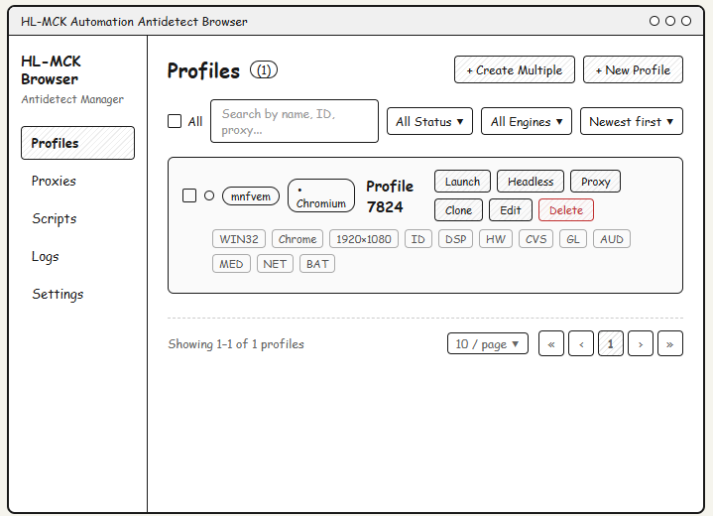
The Profiles screen allows the user to view, manage and launch browser profiles.
This screen displays a list of all created profiles with their engine, OS, resolution, and fingerprint tags.
The user can access this screen from the sidebar navigation after launching the application.
The information displayed on this screen includes profile actions. The user can launch, clone, edit, or delete profiles from this screen.
Field Name | Description
Profile Name | Displays the name of the browser profile (e.g., Profile 7824).
Chromium Badge | Label indicating the browser engine type used for the profile.
OS Tag | Badge showing the operating system (e.g., WIN32).
Browser Tag | Badge showing the browser type (e.g., Chrome).
Resolution Tag | Badge showing the screen resolution (e.g., 1920x1080).
Fingerprint Tags | Short tags representing active fingerprint modules (ID, DSP, HW, CVS, GL, AUD, MED, NET, BAT).
Launch Button | Button that launches the selected browser profile.
Headless Button | Button that launches the profile in headless mode.
Proxy Button | Button to assign or view proxy settings for the profile.
Clone Button | Button that duplicates the selected profile.
Edit Button | Button that opens the profile editor screen.
Delete Button | Button that permanently removes the profile. Shown in red to indicate a destructive action.
New Profile Button | Button that opens the New Profile creation form.
Create Multiple Button | Button for batch-creating multiple profiles at once.
Search Field | Text input to filter profiles by name, ID, or proxy.
All Status Dropdown | Filter dropdown to show profiles by status.
All Engines Dropdown | Filter dropdown to filter profiles by browser engine.
Newest First Dropdown | Sort dropdown to order profiles by creation date.
Pagination Controls | Navigation buttons to browse pages of profiles.
Per Page Selector | Dropdown to select how many profiles are shown per page (e.g., 10/page).

3.1.2 Proxy Pool Screen

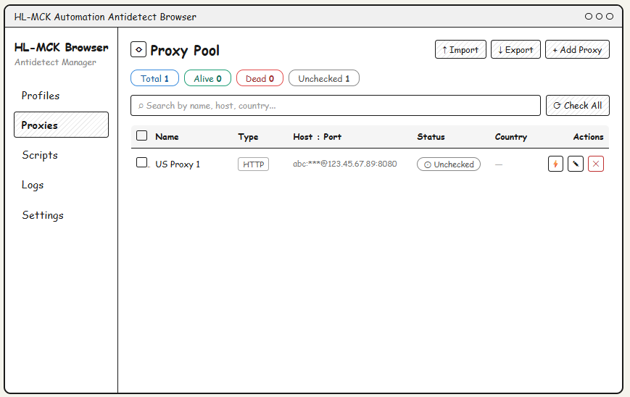
The Proxy Pool screen allows the user to view and manage all configured proxy connections.
This screen displays the proxy list with name, type, host/port, status, and country columns.
The user can add, import, export, and check proxies from this screen.

Field Name | Description
Total Badge | Shows the total number of proxies configured.
Alive Badge | Shows the number of proxies with a confirmed live connection.
Dead Badge | Shows the number of proxies with a failed connection.
Unchecked Badge | Shows the number of proxies that have not been checked yet.
Search Field | Text input to filter proxies by name, host, or country.
Check All Button | Button that triggers a connectivity check on all proxies.
Name Column | Displays the label/name assigned to the proxy.
Type Column | Shows the protocol type of the proxy (e.g., HTTP, SOCKS5).
Host : Port Column | Shows the host address and port of the proxy (credentials masked).
Status Column | Shows the current connection status (e.g., Unchecked, Alive, Dead).
Country Column | Displays the detected country of the proxy IP address.
Check Icon (Action) | Icon button to manually trigger a connectivity check for the proxy.
Edit Icon (Action) | Icon button to open the proxy edit dialog.
Delete Icon (Action) | Icon button to permanently remove the proxy. Shown in red.
Import Button | Button to import proxies from a file.
Export Button | Button to export the proxy list to a file.
Add Proxy Button | Button that opens the Add New Proxy modal dialog.

3.1.3 Scripts & Tasks Screen

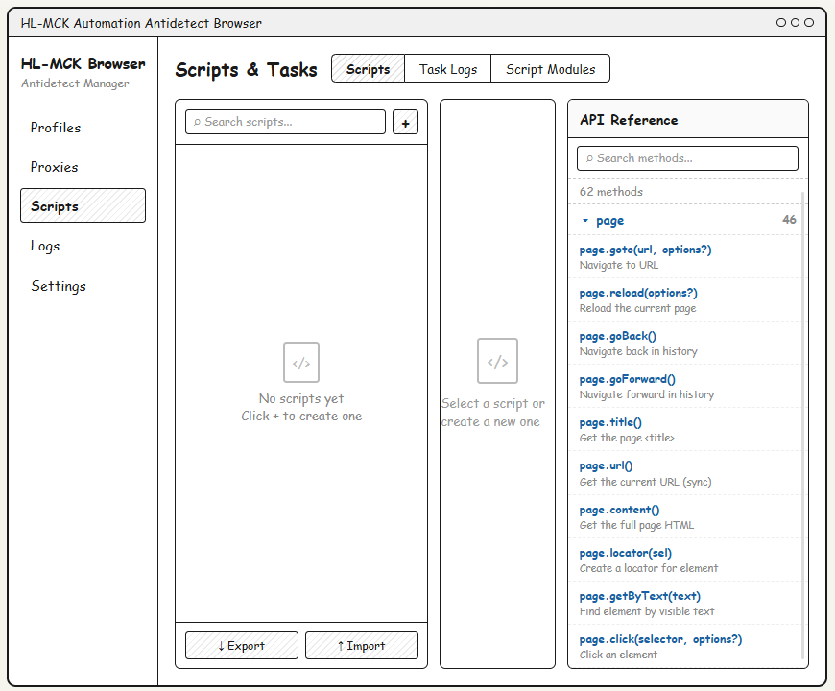
The Scripts & Tasks screen allows the user to create, manage, and run automation scripts.
The screen is divided into three tabs: Scripts, Task Logs, and Script Modules.
An API Reference panel on the right provides quick access to available page methods.
Field Name | Description
Scripts Tab | Displays the list of saved automation scripts.
Task Logs Tab | Shows execution logs for previously run scripts.
Script Modules Tab | Manages reusable script module components.
Search Scripts Field | Text input to filter the script list by name.
+ Add Script Button | Button to create a new script.
Script List Panel | Left panel listing all available scripts. Shows empty state when no scripts exist.
Script Editor Panel | Center panel for editing the selected script. Shows placeholder when no script is selected.
API Reference Panel | Right panel providing a searchable list of available page API methods with descriptions.
Search Methods Field | Text input to filter the API method list.
Method Count Label | Shows the total number of available API methods (e.g., 62 methods).
Method Group Header | Collapsible group header showing the method namespace and method count.
Method Name | Displays the method signature (e.g., page.goto(url, options?)).
Method Description | Short description of what the method does.
Export Button | Exports scripts to a file.
Import Button | Imports scripts from a file.

3.1.4 Application Logs Screen

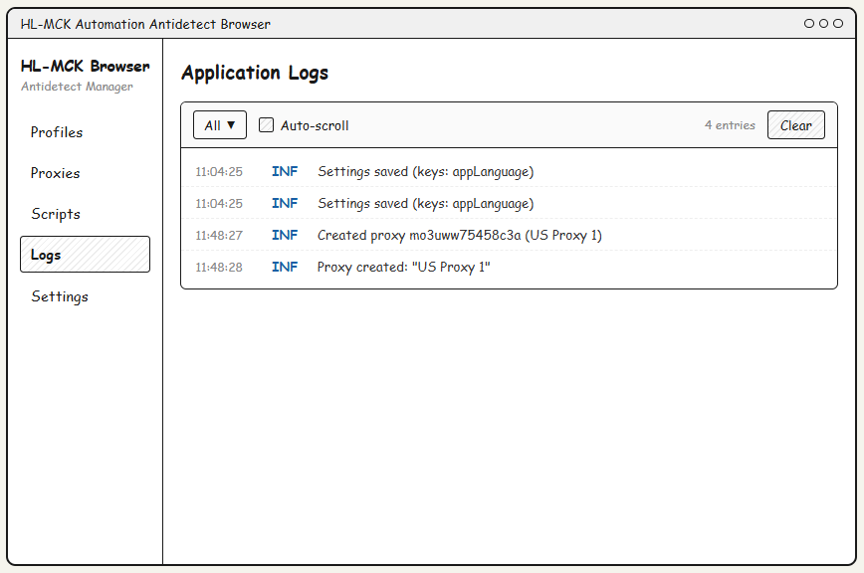
The Application Logs screen displays system-level log entries generated by the application.
Logs are shown in a list format with timestamp, level, and message columns.
Field Name | Description
Filter Dropdown | Dropdown to filter logs by level (e.g., All, INF, ERR, WARN).
Auto-scroll Checkbox | Checkbox to enable or disable automatic scrolling to the latest log entry.
Entry Count Label | Displays the total number of log entries currently visible (e.g., 4 entries).
Clear Button | Removes all current log entries from the display.
Timestamp Column | Displays the time the log entry was recorded (HH:MM:SS format).
Level Column | Shows the severity level of the log entry (e.g., INF, ERR, WARN).
Message Column | Displays the full log message text.

3.1.5 Settings Screen

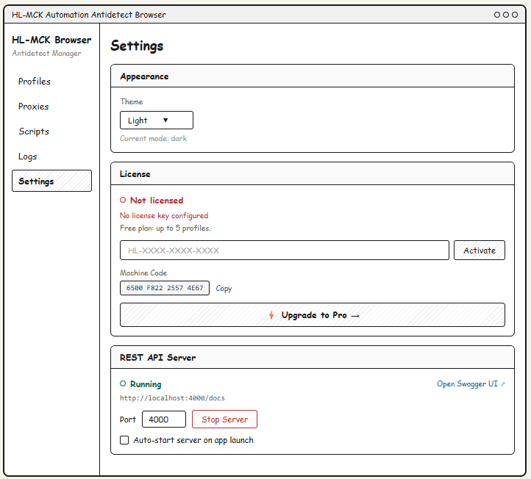
The Settings screen allows the user to configure application-level preferences including appearance, license, and the REST API server.
Field Name | Description
Theme Dropdown | Dropdown to select the application color theme (e.g., Light, Dark).
Current Mode Label | Read-only label showing the currently active theme mode.
License Status | Label indicating whether a valid license key is configured (e.g., Not Licensed).
License Warning | Text message shown when no license key is configured.
Free Plan Info | Informational text describing limitations of the free plan.
License Key Input | Text input field to enter a license key for activation.
Activate Button | Button to submit the license key and activate the product.
Machine Code | Read-only field displaying the unique machine code for license binding.
Copy Button | Button to copy the machine code to the clipboard.
Upgrade to Pro Button | Button/link to navigate to the plan upgrade page.
REST API Status | Label showing whether the REST API server is currently running or stopped.
Open Swagger UI Link | Link that opens the Swagger UI documentation page in the browser.
API Server URL | Read-only text showing the local URL of the REST API server.
Port Input | Numeric input to configure the port the REST API server listens on.
Stop/Start Server Button | Button to stop or start the REST API server.
Auto-start Checkbox | Checkbox to enable automatic server startup when the application launches.

3.1.6 New Profile - General Tab

3.1.6.1 General Tab

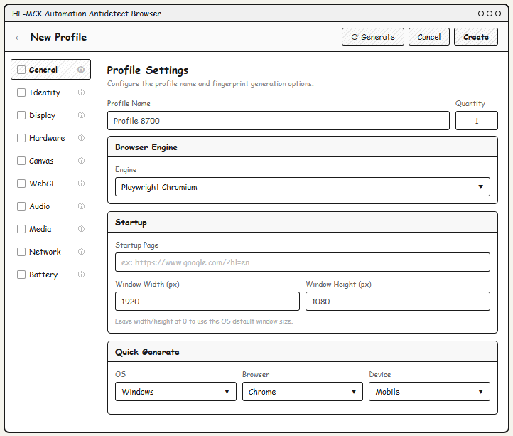
The General tab in the New Profile screen allows the user to configure the base settings for a new browser profile including the engine, startup page, and window size.
Field Name | Description
Profile Name Field | Text input for naming the browser profile.
Quantity Field | Numeric input to set how many profiles to create at once.
Engine Dropdown | Dropdown to select the browser engine (e.g., Playwright Chromium).
Startup Page Field | Optional URL input for the page that opens when the profile launches.
Window Width (px) | Numeric input for the browser window width in pixels.
Window Height (px) | Numeric input for the browser window height in pixels.
OS Dropdown (Quick Generate) | Dropdown to select the target OS for fingerprint generation.
Browser Dropdown (Quick Generate) | Dropdown to select the target browser type for fingerprint generation.
Device Dropdown (Quick Generate) | Dropdown to select the device type (e.g., Desktop, Mobile).
Generate Button | Button to auto-generate fingerprint settings based on selected options.
Cancel Button | Discards changes and returns to the Profiles screen.
Create Button | Saves the profile and adds it to the profile list.

3.1.6.2 Identity Tab

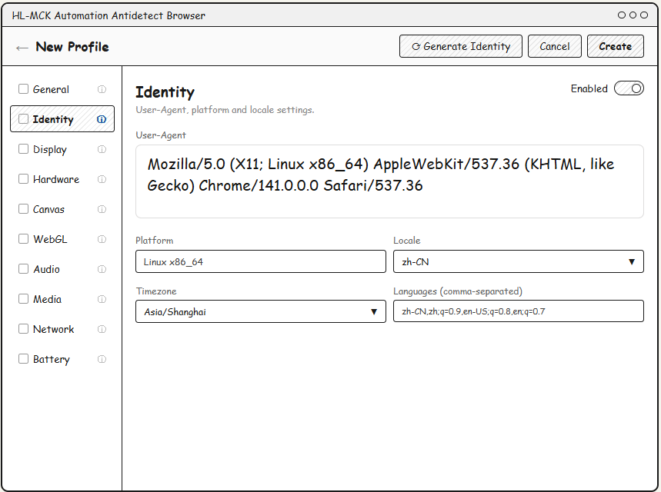
The Identity tab allows configuration of the browser's User-Agent string, platform, locale, timezone, and language settings.
Field Name | Description
Enabled Toggle | Toggle switch to enable or disable identity spoofing for this profile.
User-Agent Field | Multiline text area displaying and allowing editing of the browser User-Agent string.
Platform Field | Text input for the platform string (e.g., Linux x86_64, Win32).
Locale Dropdown | Dropdown to select the browser locale (e.g., zh-CN, en-US).
Timezone Dropdown | Dropdown to select the timezone used by the browser (e.g., Asia/Shanghai).
Languages Field | Comma-separated text input for the browser accepted language list.
Generate Identity Button | Button to auto-generate a randomized identity fingerprint.

3.1.6.3 Display Tab
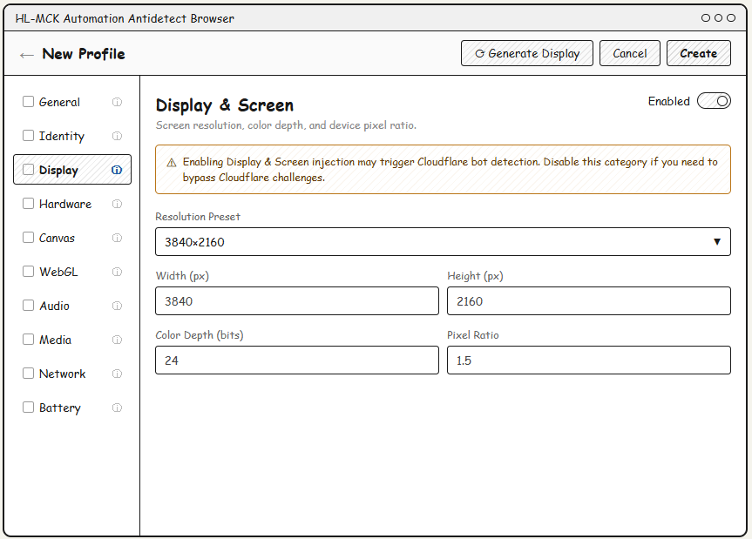
The Display & Screen tab allows configuration of the browser's screen resolution, color depth, and pixel ratio fingerprint.
Field Name | Description
Enabled Toggle | Toggle switch to enable or disable display fingerprint injection.
Warning Banner | Alert message warning that enabling this setting may trigger Cloudflare bot detection.
Resolution Preset Dropdown | Dropdown with preset resolutions (e.g., 3840x2160, 1920x1080).
Width (px) Field | Numeric input for the screen width value in pixels.
Height (px) Field | Numeric input for the screen height value in pixels.
Color Depth (bits) Field | Numeric input for the screen color depth (e.g., 24).
Pixel Ratio Field | Numeric input for the device pixel ratio (e.g., 1.5, 2.0).
Generate Display Button | Button to auto-generate a randomized display configuration.

3.1.6.4 Hardware Tab
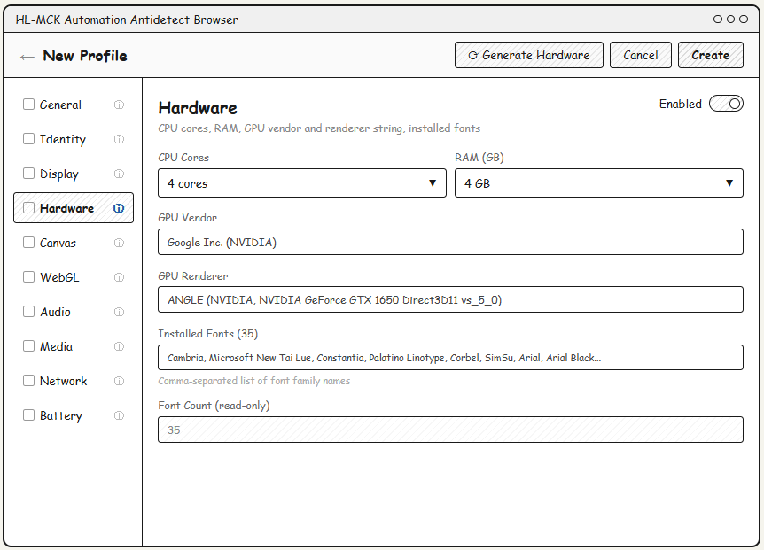
The Hardware tab allows configuration of CPU, RAM, GPU, and installed font fingerprint settings.
Field Name | Description
Enabled Toggle | Toggle switch to enable or disable hardware fingerprint spoofing.
CPU Cores Dropdown | Dropdown to select the number of CPU cores reported to the browser.
RAM (GB) Dropdown | Dropdown to select the amount of RAM reported to the browser.
GPU Vendor Field | Text input for the GPU vendor string (e.g., Google Inc. (NVIDIA)).
GPU Renderer Field | Text input for the GPU renderer string (e.g., ANGLE NVIDIA GeForce GTX...).
Installed Fonts Field | Comma-separated text input listing the fonts reported as installed.
Font Count (read-only) | Read-only field showing the count of fonts in the installed fonts list.
Generate Hardware Button | Button to auto-generate a randomized hardware fingerprint.

3.1.6.5 Canvas Tab
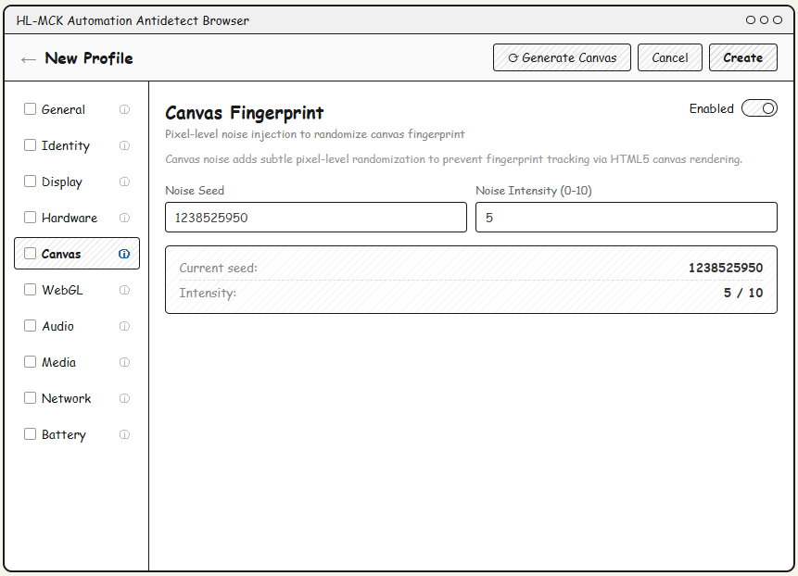
The Canvas Fingerprint tab configures pixel-level noise injection to randomize the browser's HTML5 canvas output.
Field Name | Description
Enabled Toggle | Toggle switch to enable or disable canvas fingerprint noise injection.
Description Text | Informational text explaining that canvas noise prevents fingerprint tracking via HTML5 canvas rendering.
Noise Seed Field | Numeric input for the random seed value used to generate canvas noise.
Noise Intensity (0-10) Field | Numeric input to set the intensity level of noise injection (0 = off, 10 = maximum).
Current Seed (Summary) | Read-only display showing the currently applied noise seed value.
Intensity (Summary) | Read-only display showing the current intensity value out of 10.
Generate Canvas Button | Button to auto-generate a randomized canvas noise seed.

3.1.6.6 WebGL Tab
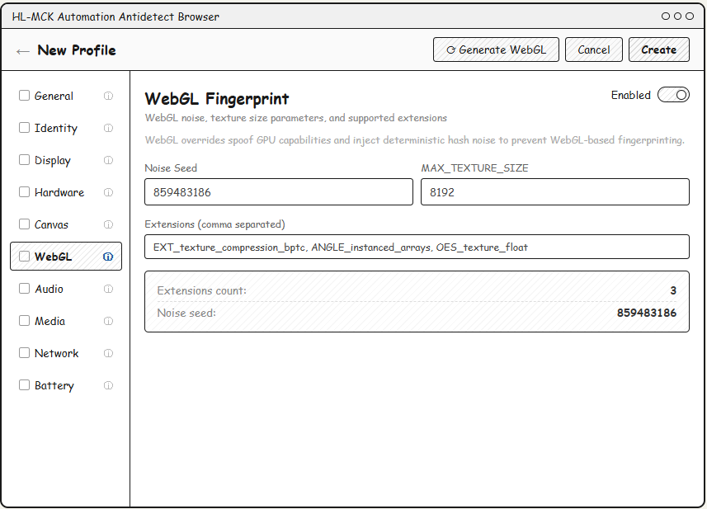
Related use cases: UC13 (New Profile - WebGL Fingerprint)
The WebGL Fingerprint tab configures GPU capability spoofing and hash noise to prevent WebGL-based fingerprinting.
Field Name | Description
Enabled Toggle | Toggle switch to enable or disable WebGL fingerprint spoofing.
Description Text | Informational text explaining that WebGL overrides spoof GPU capabilities with deterministic hash noise.
Noise Seed Field | Numeric input for the random seed used in WebGL hash noise generation.
MAX_TEXTURE_SIZE Field | Numeric input for the maximum WebGL texture size reported to the browser.
Extensions Field | Comma-separated text input listing supported WebGL extensions.
Extensions Count (Summary) | Read-only display showing the number of extensions in the list.
Noise Seed (Summary) | Read-only display showing the currently applied noise seed value.
Generate WebGL Button | Button to auto-generate a randomized WebGL fingerprint configuration.

3.1.6.7 Network Tab
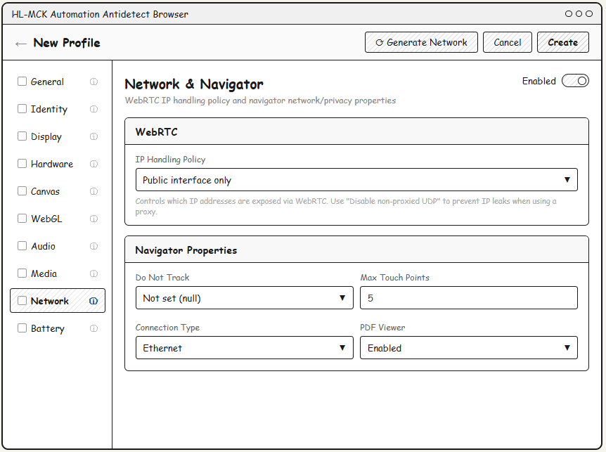
The Network & Navigator tab configures WebRTC IP handling policy and browser navigator network properties.
Field Name | Description
Enabled Toggle | Toggle switch to enable or disable network and navigator property spoofing.
IP Handling Policy Dropdown | Dropdown to set how WebRTC exposes IP addresses (e.g., Public interface only, Disable non-proxied UDP).
WebRTC Hint Text | Informational text explaining IP leak prevention when using a proxy.
Do Not Track Dropdown | Dropdown to set the navigator.doNotTrack value (e.g., Not set, Enabled).
Max Touch Points Field | Numeric input for the maximum number of touch points reported by the browser.
Connection Type Dropdown | Dropdown to select the network connection type (e.g., Ethernet, WiFi, 4G).
PDF Viewer Dropdown | Dropdown to enable or disable the built-in PDF viewer reported by the browser.
Generate Network Button | Button to auto-generate randomized network and navigator settings.

3.1.6.8 Battery Tab
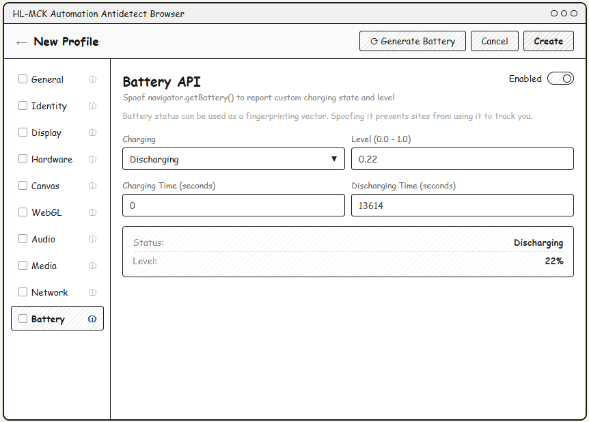
The Battery API tab allows spoofing of the navigator.getBattery() values to prevent battery-based fingerprinting.
Field Name | Description
Enabled Toggle | Toggle switch to enable or disable battery API spoofing.
Description Text | Informational text explaining that battery status can be used as a fingerprinting vector.
Charging Dropdown | Dropdown to set the charging state reported by the battery API (e.g., Charging, Discharging).
Level (0.0 - 1.0) Field | Numeric input for the battery charge level as a decimal between 0.0 and 1.0.
Charging Time (seconds) Field | Numeric input for the time in seconds until the battery is fully charged.
Discharging Time (seconds) Field | Numeric input for the time in seconds until the battery is fully discharged.
Status (Summary) | Read-only display showing the current charging status label.
Level (Summary) | Read-only display showing the battery level as a percentage (e.g., 22%).
Generate Battery Button | Button to auto-generate a randomized battery API configuration.

3.1.7 Add New Proxy

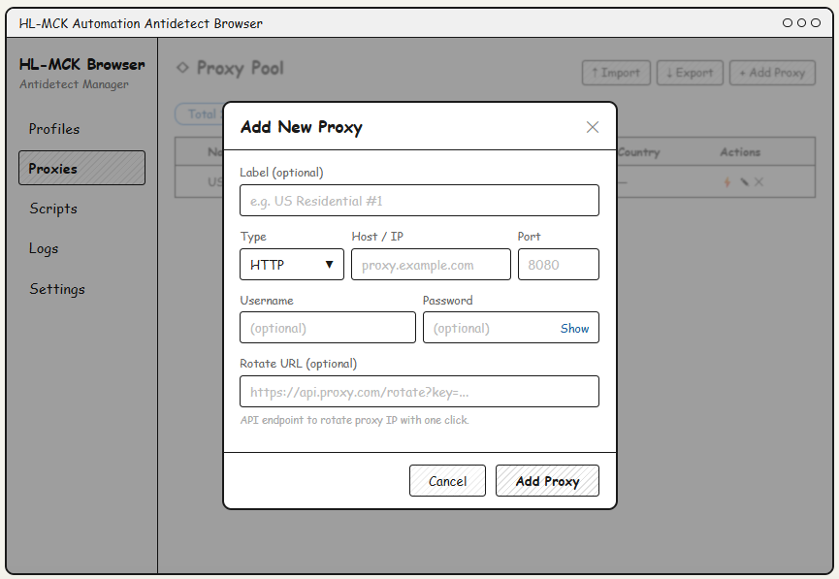
The Add New Proxy modal allows the user to manually add a new proxy connection.
This dialog is accessed by clicking the '+ Add Proxy' button on the Proxy Pool screen.
Field Name | Description
Label (optional) | Text field for assigning a human-readable name to the proxy.
Type Dropdown | Dropdown to select the proxy protocol (e.g., HTTP, SOCKS5).
Host / IP Field | Text input for the proxy server hostname or IP address.
Port Field | Numeric input for the proxy port number.
Username Field | Optional text input for proxy authentication username.
Password Field | Optional text input for proxy authentication password, with a Show/Hide toggle.
Rotate URL (optional) | Text input for an API endpoint URL to rotate the proxy IP with one click.
Cancel Button | Closes the dialog without saving any changes.
Add Proxy Button | Submits the form and adds the new proxy to the pool.

3.1.8 Browser Runtimes Screen

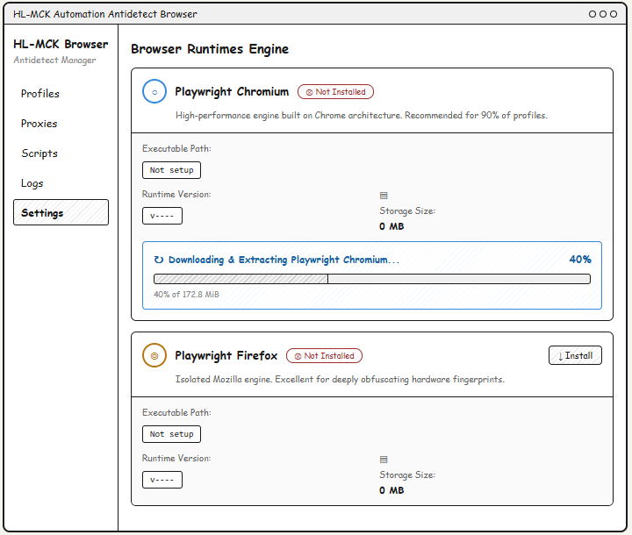
The Browser Runtimes Engine screen allows users to install and manage Playwright browser engines used for profile automation.
Field Name | Description
Engine Icon | Visual icon representing the browser engine type (Chromium or Firefox).
Engine Name | Displays the name of the browser runtime (e.g., Playwright Chromium).
Installation Status Badge | Badge indicating whether the engine is installed or not (e.g., Not Installed).
Engine Description | Short text describing the engine and its recommended use case.
Executable Path | Read-only field showing the file system path to the installed browser executable.
Runtime Version | Read-only field showing the currently installed version of the runtime.
Storage Size | Displays the disk space used by the installed runtime.
Install Button | Button to begin downloading and installing the selected browser engine.
Download Progress Bar | Visual progress bar showing the current download and extraction progress.
Progress Percentage | Numeric display of the download completion percentage.
Progress Sub-label | Text showing downloaded size vs. total size (e.g., 40% of 172.8 MiB).

3.1.9 Swagger UI Screen

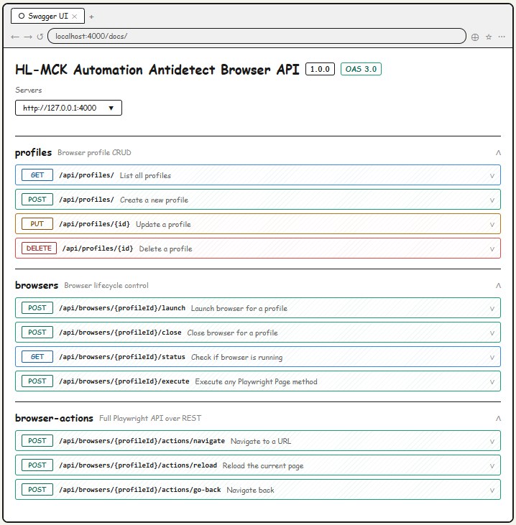

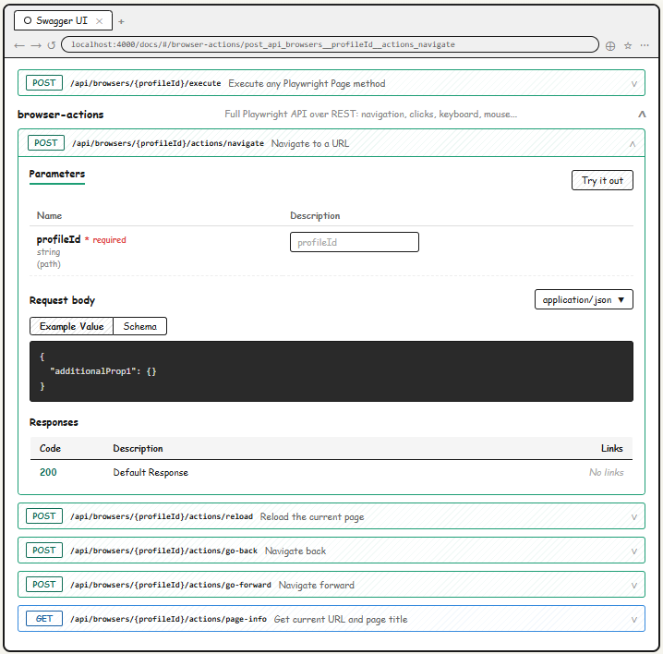
The Swagger UI page is a web-based REST API documentation and testing interface accessible at localhost:4000/docs.
It is opened from the Settings screen via the 'Open Swagger UI' link when the REST API server is running.
Field Name | Description
API Title | Displays the name and version of the REST API (HL-MCK Automation Antidetect Browser API v1.0.0).
OAS Version Badge | Badge showing the OpenAPI Specification version used (e.g., OAS 3.0).
Servers Dropdown | Dropdown to select the target server base URL (e.g., http://127.0.0.1:4000).
Endpoint Group Header | Collapsible section grouping related API endpoints (e.g., profiles, browsers, browser-actions).
Group Description | Short text describing the purpose of each endpoint group.
HTTP Method Badge | Color-coded badge showing the HTTP method (GET=blue, POST=green, PUT=orange, DELETE=red).
Endpoint Path | Shows the API route path including path parameters (e.g., /api/profiles/{id}).
Endpoint Description | Short description of what the endpoint does.
Expand/Collapse Toggle | Chevron icon to expand or collapse an endpoint's detail panel.
Parameters Table | Table listing path/query parameters, their types, and input fields for testing.
Try it out Button | Button to enable interactive API testing mode for the selected endpoint.
Request Body Section | Shows the expected JSON request body with Example Value and Schema tabs.
Content-Type Dropdown | Dropdown to select the request content type (e.g., application/json).
Code Block | Dark-themed display showing the example JSON request body.
Responses Table | Table showing possible HTTP response codes and their descriptions.
Links Column | Column in the responses table showing related API links (or No links).

4. Non-Functional Requirements

4.1 Ethical & Compliance Constraints

4.1.1 Immutable Audit Logging
The system must enforce mandatory, non-overrideable logging for all executed automation tasks. The application shall continuously record execution metadata (timestamps, active profile IDs, script identifiers) into a local tracking file. End-users must be denied privileges to delete or alter the write permissions of this log file to guarantee accountability and traceability during security compliance audits.

4.1.2 Execution Sandbox Restrictions
The automation execution Sandbox must incorporate an active validation mechanism (Linter) to intercept script payloads prior to runtime. The system shall automatically reject and forcefully terminate any automation script that demonstrates malicious patterns, explicitly including infinite loop DDoS attempts, phishing behaviors, or unauthorized background access to restricted government and financial domains.

4.2 External Interfaces

4.2.1 User Interface (UI)
The system provides a standalone Electron Desktop Application (built with React and Node.js) designed for individual machine operation. The UI allows the local User to:
- Create, edit, delete, clone, and manage isolated browser profiles.
- Deeply configure hardware fingerprint overrides (User-Agent, Canvas, WebGL, Timezone/Language, Screen Resolution, WebRTC, etc.).
- Manage proxy pools and validate proxy node connectivity (HTTP/SOCKS).
- Monitor active browser session states and view local automation execution results (live via WebSocket screencasts or textual task logs).
Minimum UI requirements:
- Clear feedback for critical non-blocking operations (loading/success/error statuses) such as launching a profile engine, testing proxy latency, and orchestrating automation scripts.
- (Note: Being a local multi-profile desktop utility, there is no generic Admin/User hierarchy—the localized desktop user possesses full operational control).

4.2.2 Public API (External API Interface)
The system exposes a powerful Local REST API server (running on localhost:4000 by default via Express) for external scripts or tools (e.g., Postman) to remotely orchestrate the application's engine.
- Communication style: REST/HTTP, payload format strictly JSON.
- Authentication: Authenticated via API Key passed in the x-api-key HTTP Header (no complex Bearer tokens needed for local execution).
- Main endpoint groups:
- Automation execution: Create/run/stop tasks, evaluate custom scripts via Playwright, and receive real-time execution logs.
- Profile & Environment management: CRUD operations for profiles, bulk proxy assignments, assigning cookies, and reading window state.
- Screencast preview: Fetch live WebSocket streams (/preview) to securely monitor background headless activities.
- API Documentation: A fully mapped OpenAPI/Swagger standard document (openapi.json) is natively served by the system at the /docs endpoint.
4.2.3 Browser Engine Integration (External Software Interface)
The core system tightly integrates with the Playwright Library and Chrome DevTools Protocol (CDP) acting as the engine drivers to:

- Launch and hook into heavily modified Chromium, Firefox, or Camoufox binary sessions based on profile configurations.
- Apply specialized runtime flags for proxy tunneling, viewport masking, and hardware spoofing overrides natively before network execution.
- Execute highly granular automation sequences (clicking, injecting keyboard events, wait states, reading cookies, and inner DOM manipulation) via decoupled execution threads.

4.2.4 Proxy Service Integration
The system includes built-in internal routing to communicate with external proxy services. It can:
- Parse and validate proxy connectivity strings (both HTTP and SOCKS protocol architectures).
- Forward profile traffic strictly through an isolated memory proxy tunnel avoiding native host IP leakage.

4.2.5 Data Storage Interface (Database/Storage)
Unlike centralized cloud services, the system relies wholly on a Local File System (JSON-driven structure) to persist data securely inside the local application's userData directory.
This includes physical files for: profiles (profiles.js), proxy pools (proxies.js), automation task logs, and system fingerprints configurations.
Browser operational scope records (Cookies, Cache, LocalStorage) are explicitly isolated into distinct physical sandbox folders (userDataDir/{profile_id}), avoiding standard relational database bottlenecks entirely.

4.3 Quality Attributes

4.3.1 Usability
A new user can complete a full operational cycle (create a profiled environment, assign a proxy, launch the spoofed engine, and execute a template automation script) within ≤ 15 minutes intuitively without extensive training.
The UI strictly enforces sequential logical rendering: Create Profile → Inject Fingerprints → Network Routing → Launch/Automation.
Complex fingerprint modifiers (WebGL vendor, Audio context, Canvas readback) default to randomized yet "safe-for-browsing" values to eliminate non-expert misconfigurations.

4.3.2 Performance & Limits

4.3.2.1 Response Time:
Standard JSON CRUD APIs (profiles/proxies/scripts): Return under < 100ms natively.
Core API Action Dispatch (Playwright actions via CDP): Executed and responded immediately (dependent largely on target host capabilities, usually < 1s).

4.3.2.2 Throughput & Concurrency:
Automation concurrency is restricted exclusively by the host Operating System's CPU/RAM allocation. Safely capable of running 2–3 heavily concurrent browser instances comfortably on a standard testing environment.

4.3.2.3 Capacity:
Storage supports essentially unlimited (≥ 200) configurations per user due to the lightweight 5KB JSON footprint of individual profiles.
The isolated browser cache (ranging between 30MB-100MB per profile) is the primary disk space consumer and is strictly monitored.

4.3.2.4 Resource Utilization:
The application architecture ensures forceful termination of memory-deadlocked Playwright processes when a session stops, reliably preventing RAM leaks and background zombie CPU executions.

5. Requirement Appendix

5.1 Business Rules

ID | Rule Definition
BR-01 | Users must activate the desktop application with a valid License Key to authenticate and access system functionalities.
BR-02 | User permissions and operational limits (for example, profile quotas or expiration dates) are strictly determined by their currently active License Plan constraint.
BR-03 | Administrators possess the authority to generate, suspend, and manage License Keys via the external Admin Dashboard, but hold absolutely no remote administrative access to user profiles.
BR-04 | All generated browser profiles and their session data (cookies, cache, storage) are structured and kept strictly on the local machine's file system, rather than synchronized to an external cloud database.
BR-05 | Each browser profile is structurally bound to exactly one cohesive fingerprint envelope configuration at a time.
BR-06 | Fingerprint and environment configurations must be saved prior to launching the browser engine; modifications saved while a browser session is running will only apply upon the subsequent restart.
BR-07 | A single browser profile can route its traffic through a maximum of one proxy configuration (HTTP/SOCKS) at any given execution time.
BR-08 | The system permits users to bind proxies to profiles regardless of whether the proxy has been pre-validated, though invalid proxies will inherently block web connectivity during execution.
BR-09 | Altering or decoupling a proxy assignment while a profile is actively running strictly requires a full profile restart to ensure network isolation integrity.
BR-10 | Browser engine core binaries must be exclusively triggered by the application's internal orchestrator (via Playwright/CDP) to ensure anti-detect hooking mechanisms are securely injected before rendering.
BR-11 | The application demands a valid installation of the targeted browser engine (e.g., Chromium/Firefox); if missing locally, the system will forcefully halt launch procedures and deploy an installation prompt.
BR-12 | Programmatic automation scripts and runtime hooks can only be evaluated and executed against an actively running, healthy profile context.
BR-13 | A running profile context is strictly limited to evaluating one linear automation script task sequence at a time to actively prevent DOM manipulation collisions.
BR-14 | Users hold the supreme authority to forcefully interrupt an executing automation script or kill the underlying browser engine at any given state.
BR-15 | Automation processes, whether successful or resulting in handled/unhandled exceptions, must export their states to local system logs directly mapped to that profile's session.
BR-16 | The Automation Script Interpreter must unconditionally intercept and block any runtime command (e.g., page navigation, API requests) targeting restricted URLs. This explicitly includes government domains (.gov), military networks (.mil), and sensitive financial/banking gateways.
BR-17 | To prevent the execution of malicious botnet operations, DDoS attacks, or click-fraud algorithms, the framework's Action Dispatcher must throttle simulated mouse clicks and keyboard typing events. The system shall enforce a hard ceiling constraint of 20 interaction events per second, per browser thread.
BR-18 | The browser profile generation engine (Client-Hints Engine) must purely synthesize all device fingerprints, canvas attributes, and operating system identifiers using cryptographic seeds. The software is strictly prohibited from accessing, scraping, recording, or transmitting the user's authentic underlying hardware data (such as genuine MAC Addresses, original IP, or physical Disk Serials).

5.2 System Messages
# | Message code | Message Type | Context | Content
1 | MSG01 | In line | No items/profiles found | No browser profiles found.
2 | MSG02 | In red, under the text box | Required fields are empty | The field is required.
3 | MSG03 | Toast message (Error) | Missing or valid License/Password | Password is required / Invalid password.
4 | MSG04 | Popup Alert (Warning) | User hits License Plan limit | The free plan is limited to a maximum of 5 profiles. Please upgrade your license.
5 | MSG05 | Toast (Success) | Connecting a Proxy to a profile | Proxy linked to [Profile Name]
6 | MSG06 | Toast (Error) | Browser engine failed to launch | Error launching profile: [Error Detail]
7 | MSG07 | Toast message (Success) | Single/Bulk create profiles | Created [X] profiles.
8 | MSG08 | Toast message (Success) | Single/Bulk clone profiles | Cloned [X] profiles.
9 | MSG09 | Toast message (Success) | Single/Bulk delete profiles | Deleted [X] profiles.
10 | MSG10 | Toast message (Success) | Live preview endpoint copied | WS endpoint copied!
11 | MSG11 | Popup Alert (Warning) | Trying to fetch WS on stopped profile | Profile is not running. Launch first.
12 | MSG12 | Popup Alert (Success) | Mass import proxy strings successfully | Imported [X] proxies ([Y] skipped).
13 | MSG13 | Popup Alert (Error) | Invalid API Proxy rotation link | No rotation URL for this proxy.
14 | MSG14 | Popup Alert (Error) | Proxy ping / Rotation failed | Rotate failed: [Unknown/Error details]
15 | MSG15 | Toast message (Success) | Local REST API Server connected | API started

5.3 Other Requirements

5.3 Other Requirements

5.3.1 Operational Environment Requirements
Attribute | Requirement
Operating System | Windows 10/11 (64-bit) – primary supported platform
Architecture | x64 processor architecture required
RAM | Minimum 4GB; recommended 8GB or more for concurrent browser session management
Disk Space | Minimum 2GB free (excluding browser engine binaries); each active browser profile may consume 30–100MB of isolated userData cache
Network | Stable internet connection required for proxy validation, License Key activation, and browser engine installation
Browser Engine | Playwright-managed Chromium/Firefox binaries must be pre-installed locally (auto-prompted on first launch)

5.3.2 Development & Runtime Platform
Component | Technology
Desktop Runtime | Electron – cross-platform Node.js desktop wrapper
Frontend Framework | React with Lucide React icon system
Backend API Server | Express.js / Fastify (Local REST API, serving on localhost:4000)
API Documentation | @fastify/swagger + swagger-ui (Auto-generated Swagger/OpenAPI served at /docs)
Browser Automation Engine | Playwright + playwright-extra + puppeteer-extra-plugin-stealth
Script Editor (UI) | Monaco Editor (the same engine powering VS Code, embedded directly in UI for writing automation scripts)
Task Scheduling | node-cron (supports periodic automation task execution via cron expressions)
Error Monitoring | @sentry/electron (automatic crash and exception reporting to Sentry dashboard)
Data Validation | Zod (schema-level request validation)
Logging | Pino / pino-pretty (structured, high-performance JSON logging)
Cryptographic Security | TweetNaCl / tweetnacl-util (License Key encryption and integrity verification)
Spreadsheet Export | xlsx (Export profile lists and task logs to .xlsx files)

5.3.3 Data Storage Requirements
Layer | Technology | Purpose
Structured Profile Data | electron-store (JSON-based local config) | Persist profiles, proxy configs, fingerprint settings to local userData
Relational Tracking | better-sqlite3 + Drizzle ORM | Structured query support for task logs, script modules, and session records
Browser Session Data | Playwright userDataDir (file system) | Strictly isolated per-profile browser cache, cookies, and localStorage
Script Runtime Modules | Local File System | User automation scripts saved and loaded from local JS/JSON module files

5.3.4 Security Requirements
- All inter-process communication between the Electron Renderer (UI) and the Main process (Node.js) are strictly routed through contextBridge (IPC), preventing direct unsafe Node.js API exposure to the frontend.
- The Local REST API requires a valid X-API-KEY header for all external automation requests; unauthenticated requests receive an HTTP 401 Unauthorized response.
- License Key integrity is verified using asymmetric cryptography (tweetnacl) to prevent local key forgery.
- The application must never transmit browser session data (profile cookies, localStorage) to any external server.

5.3.5 Compliance & Constraints
- The system must operate in a fully offline-capable mode; core profile management and browser automation functions must not require an active internet connection once browser engines and License Keys are provisioned.
- The application must never bundle proprietary browser source code; it exclusively relies on open-source Playwright-managed Chromium/Firefox binaries.
- All personal automation data remains local to the user's machine, complying with privacy-first design principles.

